**What are all the FREE resources for Spanish?**

A Hard Copy Text Book to keep at home can be checked out through the Text Book Room.

You have access to the iText through CLEVER.com

Supplemental Information is in the Teacher Website at LibertyHighSchool.com: <https://ca01001129.schoolwires.net/Page/4180>

Direct email: <https://ca01001129.schoolwires.net/Domain/1506>

You are provided: Hard Copy Guided Practices, Work Book Class Work, Text Book Class Work, Handouts, Interactive Notes, or print from attachments in CANVAS announcements.

***App: This is the text book companion.***

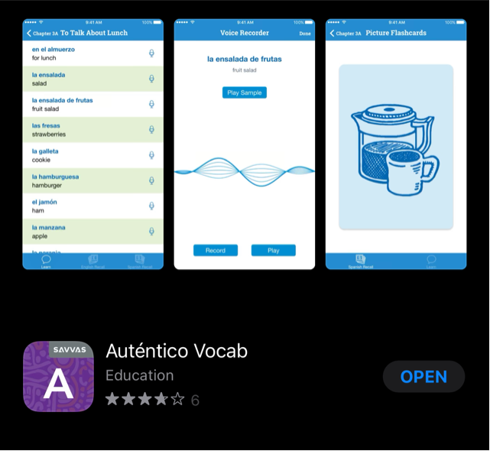

***App: Additional support in the form of language games.***

