AP Biology Mrs. Brenda Perry
Room: A111 Email: perryb@luhsd.net

AP Biology is a fast paced and challenging course designed to be the equivalent of a two-semester college Introductory Biology course. Success in this course will depend on your study skills, reading and writing abilities, motivation, and maturity. AP Biology differs significantly from Living Earth with respect to the range and depth of topics covered, laboratory work done by students, and time and effort required of the students.

Prerequisites:
Grade 11 or 12 – no exceptions
Living Earth (I recommend a B or higher)
Chemistry (I recommend a B or higher)
College Credit:
Depending on your score on the AP Exam, certain universities may give you credit for an introductory biology course. Each university is different and different scores are treated differently by different schools.
HHS AP Biology Score Report = 84% passing
National Average for AP Biology = 64% passing
Homework:
Most HW assignments are reading the assigned AP biology power points, taking notes on the power points, watching videos, and studying for assessments. This class moves fast and each unit exam covers multiple topics. Over the years, I have decreased the amount of homework I assign so students can have more time to study. This is not a class where cramming the day before a test will work!
What to Expect:
- Daily notes (most done as independent HW)
- Weekly labs
- Monthly exams (most units are completed in 3-4 weeks)
  - Expect the tests to be challenging – even top students occasionally earn low test scores.
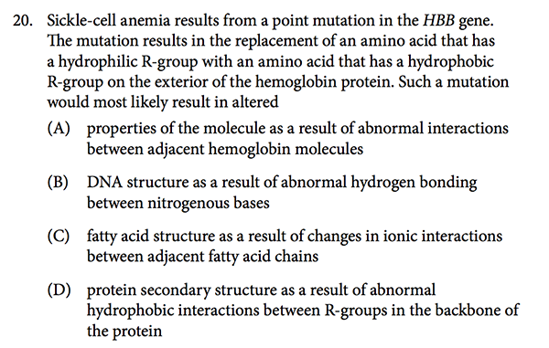
  - Look at the sample mc question below.
Things to notice:
      - Advanced vocabulary
      - College level reading level
      - Time consuming – requires pacing

