LAB- DETECTION GENETIC DISORDERS BY KARYOTYPE ANALYSIS

Objectives:
- Construct karyotypes from metaphase chromosomes of six fictitious insects
- Analyze karyotypes in order to diagnose chromosome abnormalities and disorders

Background:
A regular human cell has 46 chromosomes: 44 autosomes, which come in pairs, and 2 sex chromosomes, which specify gender (XX for female and XY for male). The pairs of autosomes are called "homologous chromosomes." One of each pair came from mom and the other came from dad. Homologous chromosomes have all of the same genes arranged in the same order, but with slight differences in the DNA sequences of the genes. What happens when a person has something different, such as too many or too few chromosomes, missing pieces of chromosomes, or mixed up pieces of chromosomes? Sometimes chromosomes are incorrectly distributed into the egg or sperm cells during meiosis. When this happens, one cell may get two copies of a chromosome, while another cell gets none. Incorrect distribution of chromosomes is called nondisjunction. If a sperm or egg cell with too many or too few chromosomes participates in fertilization, it will produce a zygote with a genetic disorder. These disorders can be diagnosed with a special test called a karyotype
A karyotype is a picture in which chromosomes of a cell have been stained so that the banding pattern of the chromosome is visible. Cells are treated with a chemical to stop the cell dividing in metaphase. The cells are then strained to show distinct parts of the chromosomes. The cells are photographed, cut, and arranged in homologous pairs according to arm length, centromere position and banding pattern. Karyotypes have become increasingly important to genetic counselors, as disorders and disease have been traced to specific visible abnormalities of the chromosomes
Rather than working with all 23 chromosome pairs found in humans, for this investigation we will assume that a new species of insect has been discovered. The insect has 3 large pairs of chromosomes. Researchers have been able to trace four genetic disorders to specific chromosomal abnormalities in this insect species. Study the karyotype as well as the appearance of the chromosomes for the normal male and female of the insect.

Materials

- Scissors
- Glue
- Chromosomes scatters photocopies
- Analysis worksheet

Procedure:
- Obtain copies of the chromosome scatters for each of the six insects
- Cut out the chromosomes for insect one and arrange them on the line designated for insect one
- Pair the homologous chromosomes, by comparing the size, location of centromere and banding pattern
- Make sure that you place the centromere on the line, so it is easier to compare the sizes and banding
- Be sure to line up chromosomes in the order that is shown in the karyotypes of the normal male and female
- Once the chromosomes are positioned, glue them into place.
- Repeat the steps above for insects 2-6

Figure 1--- Karyotypes for Normal Female and Male insects
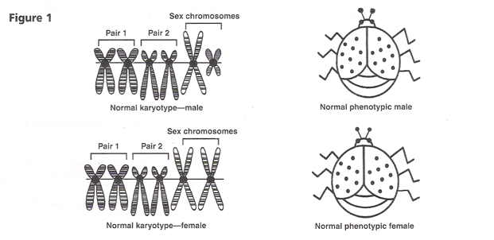
Note that the normal male insect has a pair of sex chromosomes similar to those of a human male, one is large and one is much smaller. In the same way the female has a pair of sex chromosomes similar to those of the human female, they are both large.
These sex chromosomes make up chromosome pair 3 for this insect; in humans it would be the 23rd pair.

DIAGNOSING DISORDERS

These insects will either be normal or have one of the four chromosome disorders; monosomy, trisomy, deletion or duplication. You will also use the metaphase chromosomes to determine gender for each of the insects
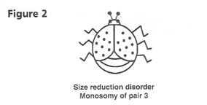

The disorder known as size reduction appears when there is a monosomy of the sex chromosome pair. A single large chromosome produces a small female insect and a single small chromosome produces a small male insect. This disorder is shown in (Figure 2)

*******************************************************************************

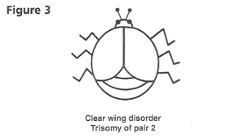

Clear Wing disorder appears to result from a trisomy of the chromosomes of pair 2. The extra chromosome of the second pair produces sterile insects that lack color in their wings. Since sterility always results, the clear wing disorder is not passed on the their offspring. (Figure 3). A similar genetic disorder in humans might result in Down’s Syndrome.

*********************************************************************************
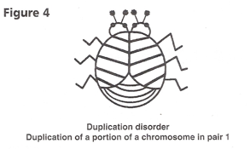

A duplication of a portion of a chromosome from pair 1 produces an insect with two heads. This duplication also produces banding on the wings and additional body segments. (Figure 4)

*******************************************************************************

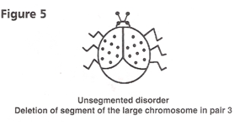

The deletion of a short segment of the large sex chromosome results in a loss of body segmentation and reduces the body size. (Figure 5)

*******************************************************************************

Name _____________________________________ Per_____________
HOW CAN A KARYOTYPE ANALYSIS DETECT GENETIC DISORDERS? (25 POINTS)
- What are homologues chromosomes?

  - How many autosomes do these insects have?
  - How many autosomes do humans have?

- How many sex chromosomes do these insects have?
  - What does a female look like?

  - What does a male look like?

- What does the term diploid mean?

  - How many copies of each chromosome should the insects have?

- What is a Trisomy?
  - Give an example that we see in real organism

- What is a Monosomy?
  - Give an example that we see in real organism

- Based on your notes, describe the steps needed to complete a karyotype in a real organism

- What kind of information is needed to figure out if the insects have a genetic disorder or not?

  - Why is it so important to have this step?

- What phase of the cell cycle are these cells in when the karyotype is created?

- What 4 things should be taken into account when looking at the chromosomes in the karyotype?

- Identify the Sex, Chromosome Error and Genetic Disorder for each of the fictitious insects
 | SEX | CHROMOSOME ERROR | GENETIC DISORDER
INSECT 1 |  | None | Normal
INSECT 2
INSECT 3
INSECT 4
INSECT 5 |  | None | Normal
INSECT 6

- Which chromosomal error was most difficult to “diagnose” using the karyotype?
  - Why was it so hard to diagnose?

- Which chromosomal error was the easiest to see using the karyotype?
  - Why was it so easy to diagnose?

- How do you think that the duplication of a chromosome can produce double heads and also affect the body segmentation and wing pigment?

- Which of the disorders can’t be passed on to offspring and why it can’t be passed on.

- List 3 ways that this activity is similar to a real life human karyotype

Extra Credit---Try it in a human http://learn.genetics.utah.edu/content/chromosomes/karyotype/ provide a screen shot of the completed form as proof.
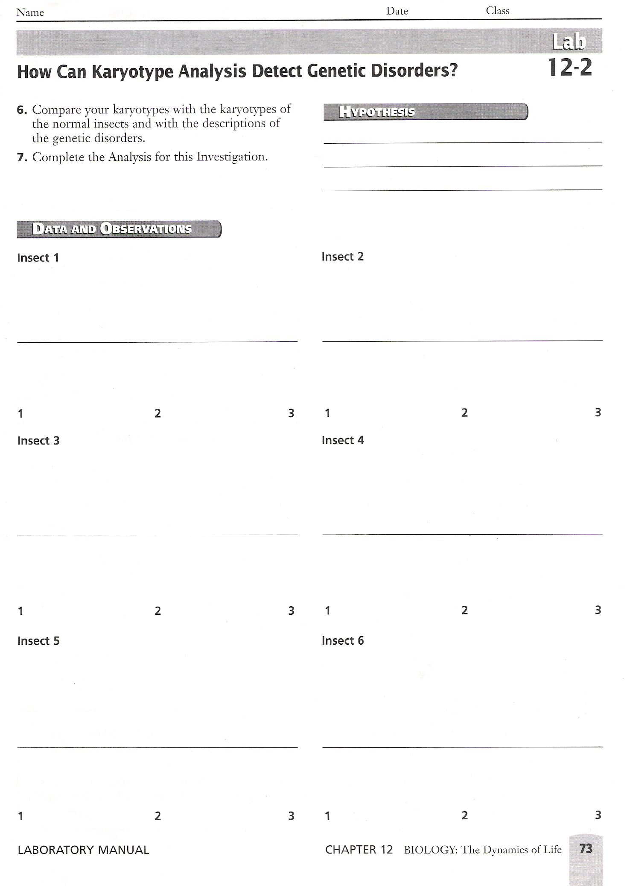
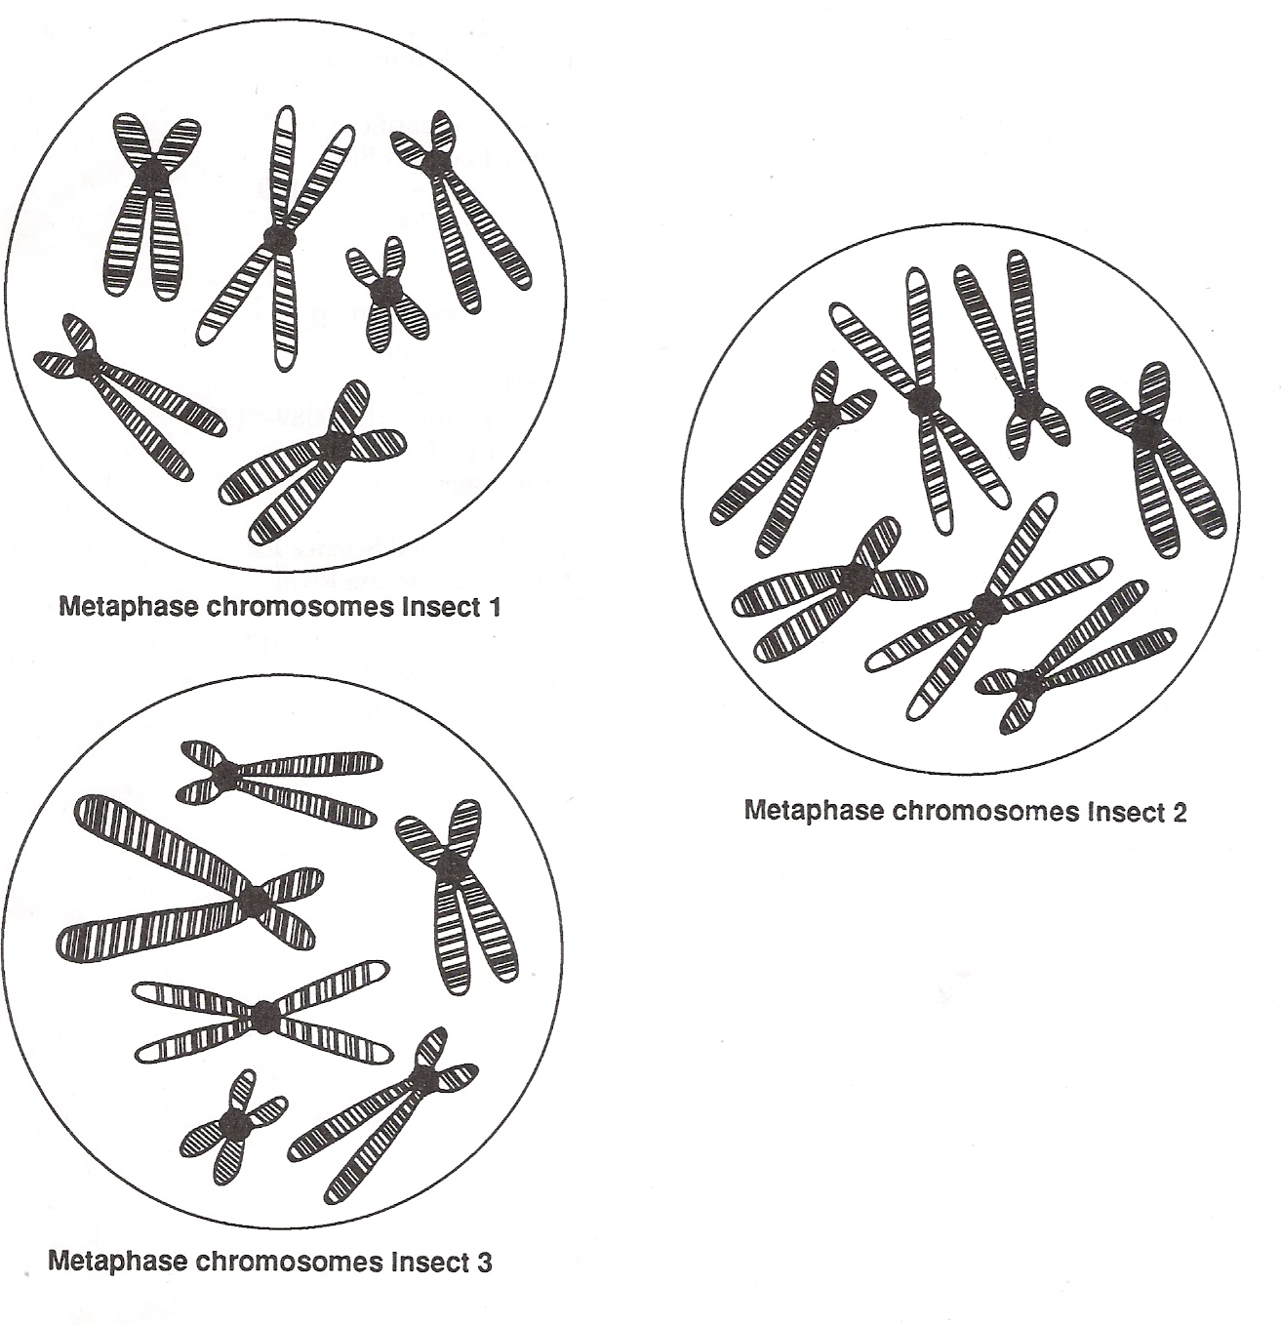
Only cut out one Bugs Chromosomes at a time
or you will get them all messed up!

