Lesson 1: The Chief Executive

Preview

|  |
| --- |
| Do Now: Watch the intro to the video “Article II of U.S. Constitution” (0:00-5:27) and answer the prompts.   1. What is established in Article II? 2. What options did the framers consider when they created the executive branch? 3. What were their concerns about establishing a single executive? Why did they ultimately decide to do so? |

|  |  |
| --- | --- |
| Political Dictionary | Essential Question |

|  |
| --- |
| Introduction   1. In your opinion, what is the appropriate term for POTUS? Explain. 2. Do you believe in term limits? Why or why not? |

Reading Notes

1. Formal Qualifications: The Constitution requires the President to be…

|  |  |
| --- | --- |
| Qualifications | Description |
| Age |  |
| Citizenship |  |
| Residency |  |

1. Informal Qualifications: Americans tend to like presidents who are…

|  |  |
| --- | --- |
|  |  |
|  |  |

1. What is the *Electoral College*?
2. What is a president’s term in office?

|  |
| --- |
| *Amendment 22:* |

1. How is presidential succession determined?

|  |
| --- |
| *Amendment 25:*   * Section 1: * Section 2: * Section 3: * Section 4: |

|  |
| --- |
| *Presidential Succession Act:* |

1. Identify and explain the four main groups of the executive branch.

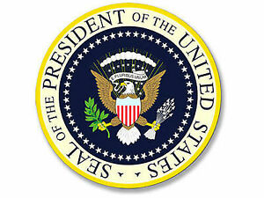

|  |
| --- |
| *White House Staff*: |
| *Executive Office of the President*: |

|  |
| --- |
| *Executive Departments*: |

|  |
| --- |
| *Independent Agencies*: |

Processing

The current White House staff, includes…

* Chief of Staff:
* Director of Communications:
* Press Secretary:
* White House Counsel:
* Staff Secretary:
* Assistants: