Name: ____________________________________________________ Date: _________________ Period: __________

Heating Curve Practice

A
C
B
D
- _____________ What letter on the graph represents the solid state?
- _____________ What letter on the graph represents the liquid state?
- _____________ What letter on the graph represents melting?
- _____________ What is the melting point of aluminum, based on this graph?
- _____________ What letter on the graph represents boiling?
- _____________ What is the boiling point of aluminum, based on this graph?
- _____________ How much energy is needed to melt the substance, based on this graph?
- _____________ How much energy is needed to boil the substance, based on this graph?
- _____________ What takes more energy, boiling or melting?

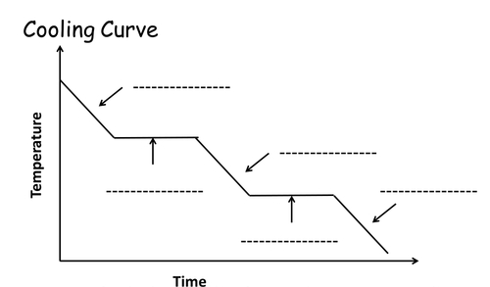
- Label each part of the cooling curve to the left.
- Mark on the y axis where the condensation point is.
- Mark on the y axis where the freezing point is.
- In the heating curve for carbon dioxide there is only one plateau—the substance goes directly from solid state to gaseous state. What state change does this plateau represent? What state change would the plateau represent in the cooling curve?

