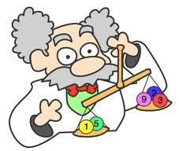
Name: ___________________________________________________ Date: ________________________ Period: _____

An Introduction to Balancing Equations
Adapted from Chemistry: A Study of Matter

Fill in the blanks with the most appropriate term:

A ___chemical____ ___equation__ tells the story of a chemical reaction. _________________ are the starting substances in the reaction while _________________ are the new substances that are formed. The large numbers in front of some of the formulas are called ________________. These numbers are used to ________________ the equation because chemical reactions must obey the Law of _________________________ of Matter. The number of atoms of each element on both sides of the equation must be _________________ because matter cannot be __________________ or ___________________. When balancing equations, the only numbers that can be changed are ___________________; remember that ___________________ must never be changed in order to balance an equation.

Balance the following equations (you must show your work using a RAP Table on a separate piece of paper)

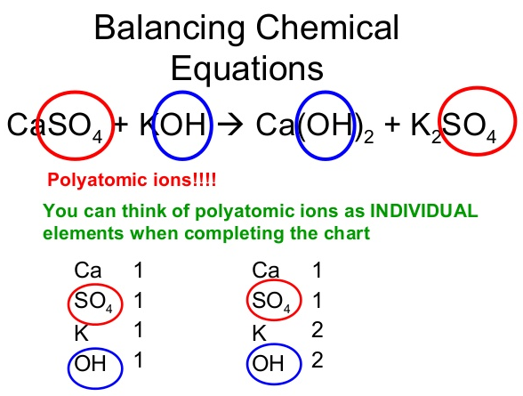
- Al + O₂ Al₂O₃

- C₃H₈ + O₂ CO₂ + H₂O

- Al(NO₃)₃ + NaOH Al(OH)₃ + NaNO₃

- KNO₃ KNO₂ + O₂

- O₂ + CS₂ CO₂ + SO₂

- KClO₃ KCl + O₂

- BaF₂ + K₃PO₄ Ba₃(PO₄)₂ + KF

- H₂SO₄ + Mg(NO₃)₂ MgSO₄ + HNO₃

- Al + H₂SO₄ Al₂(SO₄)₃ + H₂

- WO₃ + H₂ W + H₂O

