Name: ______________________________________________ Date: ___________________________ Period: _______

Summative 1.6, 2.1 and 2.2 – Study Guide

Learning Target 1.6 – Systems and Energy Flow

- Identify the systems and the surroundings in the following examples. Which way is the energy flowing? (Draw a diagram using arrows to represent the energy flow).
  - When a small quantity of ammonium chloride (NH4Cl) is dissolved in water in a test tube, the tube becomes colder than before.

  - Burning a log in the fireplace to heat up the living room.

  - A hot pack is made up of two bags (one contains water and one contains calcium chloride). When the calcium chloride reacts with the water, it gives off heat.

  - Adding ice to a glass of soda will cool down the soda

- Complete the following table by defining the types of energy and sorting the examples into the appropriate boxes.
Kinetic Energy | Potential Energy
Definition: | Definition:
Examples to be sorted: Cheetos in a bag, A glass of milk on the table, Weasels weaseling, A student taking notes, chemical energy, a skier at the top of a mountain, a bird in its nest at the top of a tree

Learning Target 2.1 – Kinetic Molecular Theory

- A substance at 10°C and a substance at 20°C are compared in a lab. Which has more energy? Why?

- In the boxes below, draw the particles and movement for solids, liquids, gases. Which has the highest KE? Which has the largest spaces?

- Which state(s) of matter can change its shaped?

- Which state of matter is most easily compressed – why?
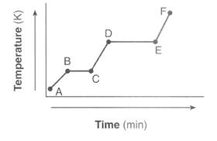
Learning Target 2.2 – Heating and Cooling Curves

- Use the heating curve to the right to answer the following questions:
  - Label the states of matter on the graph.
  - Label the phase changes on the graph.
  - What is happening to the energy (KE & PE) at line BC?

  - What is happening to the energy at line DE?

- Sketch the corresponding cooling curve for question 7. Label the states of matter, the phase changes, and discuss the changes in KE and PE along each line.

- In what part of the curve would substance X have definite volume and shape?

- What part of the curve represents a mixed liquid/vapor phase?

- What is the melting point of substance X?

- In what part(s) of the curve would increasing kinetic energy be displayed?

- What is happening to the potential energy in part IV?

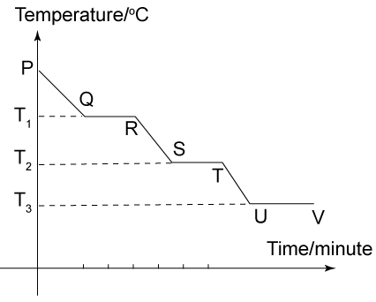

- In what segment of the curve would substance Y have indefinite shape and definite volume?

- What is the freezing point of substance Y?

- What is happening to the energy at segment RS? (Indicate what type of energy you are talking about)

- What is happening to the energy at segment ST? (indicate what type of energy you are talking about)

