Name: ______________ANSWER KEY___________________ Date: ______________________________ Period: _________

Summative 3.1, 3.2, 3.3 Study Guide – ANSWER KEY

Learning Target 3.1

- Complete the following table.
Element | Symbol | Atomic # | Atomic Mass | # protons | # neutrons | # electrons | Nuclear Symbol
Argon | Ar | 18 | 40 | 18 | 22 | 18 | $\begin{matrix}40 \\ 18\end{matrix}$Ar
Cadmium | Cd | 48 | 112 | 48 | 64 | 48 | $\begin{matrix}112 \\ 48\end{matrix}$Cd
Praseodymium | Pr | 59 | 140 | 59 | 81 | 59 | $\begin{matrix}140 \\ 59\end{matrix}$Pr
Lead | Pb | 82 | 207 | 82 | 125 | 82 | $\begin{matrix}207 \\ 82\end{matrix}$Pb
Tungsten | W | 74 | 184 | 74 | 110 | 74 | $\begin{matrix}184 \\ 74\end{matrix}$W

Learning Target 3.2

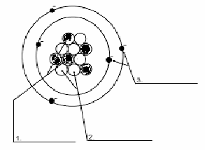
- Label the parts of the atom to the right. What is the charge on each subatomic particle? Identify where the mass is located and where the volume is located.
Proton = +1
Electron
Neutron = 0
Electron = -1
Nucleus = Mass
Electron cloud = Volume
Neutron
Proton

- Draw Bohr models for Lithium, Calcium, Neon, and Phosphorous. How many valence electrons does each one have?
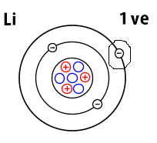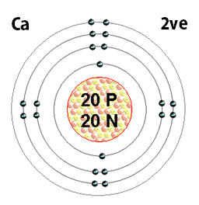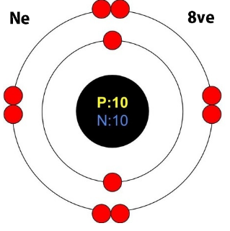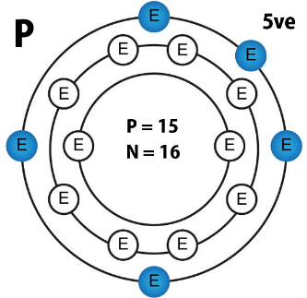

Learning Target 3.3
- If an atom has 5 valence electrons…
  - Will it gain or lose electrons? gain (element wants to reach full shell of 8, thus it gaining 3 electrons is easier than losing 5 electrons)
  - How many will it gain or lose? 3
  - What will its charge be? -3 (each electron is a -1 charge, if you gain 3 electrons, you change your charge by -3)
- If an atom has 2 valence electrons…
  - Will it gain or lose electrons? lose (element wants to reach full shell of 8, thus it losing 2 electrons is easier than gaining 7 electrons)
  - How many will it gain or lose? 2
  - What will its charge be? +2 (each electron is a -1 charge, if you lose two electrons, you change your charge by +2)
- Complete the following table.
Element | Ion Symbol | Atomic # | Atomic Mass | # protons | # neutrons | # electrons | Nuclear Symbol (include charge)
Cobalt | Co²⁺ | 27 | 59 | 27 | 32 | 25 | $\begin{matrix}59 \\ 27\end{matrix}$Co²⁺
Aluminum | Al³⁺ | 13 | 27 | 13 | 14 | 10 | $\begin{matrix}27 \\ 13\end{matrix}$Al³⁺
Palladium | Pb²⁺ | 46 | 106 | 46 | 60 | 44 | $\begin{matrix}106 \\ 46\end{matrix}$Pb²⁺
Cesium | Cs²⁺ | 55 | 133 | 55 | 78 | 53 | $\begin{matrix}133 \\ 55\end{matrix}$Cs²⁺
Iodine (-1) | I⁻ | 53 | 127 | 53 | 74 | 54 | $\begin{matrix}127 \\ 53\end{matrix}$I⁻

- Why does iodine form an ion?
Iodine has 7 valence electrons. All elements want to have a full shell/orbit/energy level of electrons to be stable. In this case, iodine wants 8 valence electrons (octet rule). In order to get 8 electrons, iodine will form an ion (unequal amounts of protons and electrons) to get its full shell.

