Nutrition Labels & Food Safety
Chapter 10 Lessons 4

- Nutrition Label Basics
  - ________________________________
    - _____________________________ amounts first; Food additives
  - ________________________________
    - ________________________: A single serving
    - Provides information about the nutrients found in the food
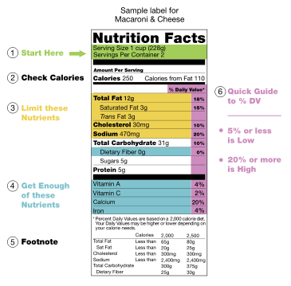
Total Maximum Daily Intake
  - Calories = __________
  - Total Fat = _____g or less
  - Saturated Fat = ____g or less
  - Cholesterol = ______mg or less
  - Sodium = ________mg or less
  - Sugar = _____g or less
- Food Safety
  - ________________________________________________ (food poisoning)
    - Eating/drinking something that contains a _______________or disease causing _______________
    - _______________________________: selecting, storing, cooking & handling food properly; prevent cross-contamination
    - ____________________________________:
      - Replace/wash dishcloths & hand towels often, Keep frig at 41F, Wash hands, cooking utensils & surfaces w/warm soapy water, Cook food thoroughly
- And Food Sensitivity
  - _________________________________________
    - ______________________________ responding to food as if it was a disease causing agent
    - Results from body reaction to the foreign proteins in food
  - ____________________________________________
    - Negative reaction to food that ________________________ involve the immune system
    - Irritates the intestine

