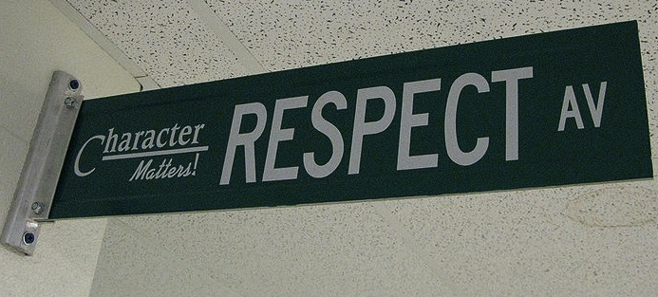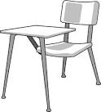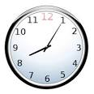

Health Ed

## Evaluation and Late Assignments

I evaluate classwork, homework, projects (both in and out of class), tests/quizzes and other assignments. Each student should put forth their best effort and be concerned about their grade from the first day of class. Points are accumulated from the beginning of the semester until the end – your grade is cumulative and will not be the average of the two quarters.

Late work is accepted but is ***only worth half of the points***that you have earned on that assignment and you only have ***one week after the due date to turn the assignment in***. Keep all work until the conclusion of the semester in your notebook.

Welcome to Health Education. This course is designed to provide information and knowledge that support a health conscious lifestyle. Students will be able to identify the importance of being health literate, demonstrating higher thinking and problem solving skills when confronted with health problems and issues. Students will also be able to present examples that support a health lifestyle, display competence to use basic health information in health enhancing ways now and in the future.

Class Content:

* Mental and Emotional Well-Being
* Nutrition and Physical Fitness
* Substance Use and Abuse
* Family Life and Reproductive Health
* Diseases and Disorders

# Course Description

#### Be kind & be respectful.

### Class Expectations

#### Follow directions the first time they are given.

#### Raise your hand and wait to be called on before speaking.

All school rules also apply.

#### Ask permission to leave your seat.

#### Be on time & be prepared.

Meeting classroom expectations and behaving appropriately in class helps to create a learning environment where you and your classmates feel welcome, safe, and respected.

Here is a reminder of the Falcon Five – these core values and concepts will help you be successful in and out of the classroom.

Be Prepared

Be Respectful

Be Positive

Be Accountable

Be a Falcon!!

I am excited to learn with you and I hope that we have a positive and productive semester!

**Bring this sheet home, review with your parent(s), have them sign the bottom and place in your notebook.**

## The Falcon Five

**Class Rules:**

1. Any homework that is turned in after I have collected it at the start of class will be marked late and will only be worth half credit.
2. No foul language, inappropriate remarks or comments will be used in the classroom at any time.
3. No electronic devices, toys, skateboards, etc. are allowed.
4. No food, drink, or gum in the classroom.
5. The school attendance/discipline policy will be followed.
6. If caught copying or cheating, the grade for the assignment in question will earn an F with no opportunity for make-up and parents will be notified.
7. Students will be attentive and participate during lectures or class discussions
8. Respect school and personal property; be courteous, respectful and considerate to others.

**Student Responsibilities:**

1. Students are to come to class prepared with materials to work every day.
2. Stay focused and on task at all times.
3. Make up all missing work, tests and quizzes – be accountable.
4. Be responsible for your own actions.
5. It is your responsibility to find out any missed assignments, tests or quizzes and to get the notes for any absences.

**Grading Policy:**

Grades are weighted as shown below:

Assessments/Projects – 55%

Homework– 25%

Professional Participation – 20%

* Attending and participating in class 10/10
* Coming to class tardy 5/10
* Absent 0/10

**Grading Scale:**

A= 100 – 90 B = 89 – 80

C = 79 – 70 D = 69-60

F = 59 and below

**YOU WILL NEED:**

* A spiral bound notebook
* Writing utensils (pens or pencils)
* Dry Erase Marker with eraser
* Your own set of printed class notes. You can access them through my website:
* A positive attitude, a sense of humor, & an open mind

## Classroom Policies, Student Responsibilities, & Grading