Name: _________________________________________________________ Date: _______________ Period: ________

Calorimetry Practice (Specific Heat Practice #3)

Important equation: Q = mCΔT ΔT = Tfinal - Tinitial For Water, C = 4.184 J/g °C or C = 1.00 cal/g °C

1. How much heat is transferred when 57 grams of mercury cools from 76 °C to 18 °C? The specific heat of mercury is 0.14 J/g°C. **[Ans: - 460 J]**
2. What is the specific heat of a substance that absorbs 2500 joules of heat when a sample of 1000.0 g of the substance increases in temperature from 10.0°C to 70.0°C? **[Ans: 0.042 J/g°C]**
3. A total of 54.0 joules of heat are absorbed a piece of lead is heated from 12.0°C to 42.0°C. If the specific heat of lead is 0.129 J/g °C, what mass of lead was used? **[Ans: 14.0 g]**
4. A cube of gold weighing 192.4g is heated from 30.0°C to some higher temperature, with the absorption of 226 joules of heat. The specific heat of gold is 0.030 J/g∙°C. What was the final temperature of the gold?

**[Ans: 69 °C]**

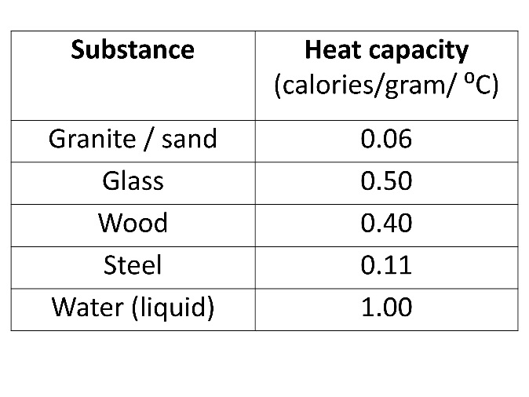

1. You have a beaker or cool water. You drop a piece of glass that has been heated to 200.0 °C into the water.
   1. The temperature of the glass will _______________________ and the temperature of the water will ____________________________. The temperature will stop changing when the two temperatures are ______________________ (this is called thermal equilibrium). All the heat lost by the glass will be absorbed by the _____________________________ because of the Law of ___________________________________________________________.
   2. Consider the heat capacity in the table. Will the glass or water have a larger temperature change? Why?
2. If the glass in the previous problem had a mass of 25.0 g and cooled to 40.0 °C, how much heat would be released? (Use the specific heat from the previous table—your answer will be in calories).
3. If the beaker contained 100.0 grams of water and had an initial temperature of 20.0 °C, how much heat would be absorbed by the water? (Remember—the final temperature of the glass and water is the same, 40.0 °C) (Use the specific heat of water in *calories*)
4. You should notice that both 6 & 7 have the same numerical answer, but #6 is negative. Explain why.

Because of the Law of Conservation of Energy, all energy lost by the glass must go into the water (or surroundings). Because of this, we can say that Qgained = − Qlost. We can apply this to our calculations. Try it here:

1. When a 212 gram sample of iron at 93.50C was added to 53.5 grams of 36.5°C water, the final temperature is 40.00. Calculate the specific heat of iron. **[Ans: 0.0691 J/g°C]**

Qwater= −Qiron

(mcΔT)water = -(mcΔT)iron

(__________ g)(4.184 J/g °C)(__________ °C) = − (__________ g) **Cp for Iron** (__________ °C)

Mass water ΔT for water Mass iron ΔT for iron

After you plug everything in, simplify and solve for C!

Try it on your own:

1. A 100.0 g ball of an unknown metal at 100 °C is dropped into 70.0 g of water at 20 °C in a coffee cup calorimeter. The final temperature of the water is recorded as 30 °C. What is the specific heat of the metal? Assume the specific heat of water is 4 J/g °C. **[Ans:** **0.4 J/g°C]**