# Name: ______________________________________ Date: _________________________ Period: ______

# And You Think You Have Significant Problems?

**Significant Figure Rules & Practice**

**MCj02515130000[1]**

**Important Ideas**

* Measurements (3.25 cm) are different than numbers (3.14159252).
* Measurements consist of a number and units.
* Measurements are an action by someone with a measuring instrument.
* Measurements have built-in uncertainty; no measurement is exact.

**PAPER CLIP:**

**1. Estimate the length of the paperclip using each of the rulers given below…**

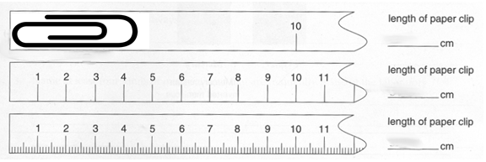

**LENGTH:**

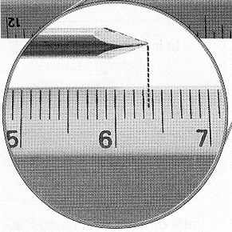**1. In the picture at right, the scale on the ruler reads to the nearest ____________. This means that we can reasonably estimate to the ______________ place. Therefore, we might say that the length of this nail is ________________.**

**VOLUME:**

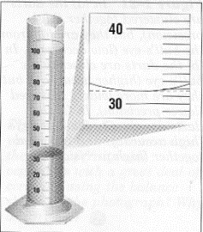

**2. In the picture at left, the scale on the graduated cylinder reads to the nearest ____________. This means that we can reasonably estimate to the _____________ place. Therefore, we might say that the volume of water shown here is __________.**

**Significant Figure Rules**

1. ________________________________________________________________!

2. ________________________________________________________________!

3. ________________________________________________________________!

4. ________________________________________________________________!

5. When we **MULTIPLY/DIVIDE**, your answer is rounded to the fewest number of **_______**.

6. When we **ADD/SUBTRACT**, your answer is rounded to the smallest __________.

**PRACTICE PROBLEMS:**

1. **Determine the number of significant figures in each measurement.**

1.) 6.751 g 4.) 2500 m 7.) 0.106 cm 10.) 26.509 g 13.) 2.690 g

2.) 0.157 kg 5.) 700. G 8.) 0.0067 g 11.) 54.52 cm3 14.) 43.07 cm

3.) 28.0 nm 6.) 30.07 g 9.) 0.0230 cm 12.) 0.1209 m 15.) 635200l g

1. Multiply/Divide the following, and write your answer with the correct number of significant figures. PLEASE BE CAREFUL ABOUT YOUR UNITS!!!

**RULE: When we multiply/divide, your answer is rounded to the fewer # of ____ ____.**

1. 2.6 cm x 3.78 cm
2. 6.54 m x 0.37 m
3. 0.036 m x 0.0002 m
4. 3.08 km x 5.2 km
5. 35 cm2 ÷ 0.62 cm
6. 39 g ÷ 24.2 g
7. 0.58 dm3 ÷ 2.15 dm
8. 40.8 m2 ÷ 5.050 m
9. Add/Subtract the following, and write your answer with the correct number of significant figures. DON’T FORGET ABOUT UNITS!!!!

**RULE: When we add/subtract, your answer is rounded to smallest _________ place.**

## 16.5 cm + 8 cm + 4.37 cm

1. 13.25 g + 10.00 g + 9.6 g
2. 2.36 m + 3.38 m + 0.355 m + 1.06 m
3. 0.0853 g + 0.0547 g + 0.037 g + 0.00387 g
4. 40.8 m2 ÷ 5.050 m
5. 13.57 g - 6.3 g
6. 350.0 m – 200 m
7. 27.68 cm –14.369 cm