Name: __________________________________________________________ Date: _______________ Period: _______

Review of the Periodic Table

For our next unit, we are going to be investigating the different types of bonds elements can form with each other. For this unit you will need to remember important concepts about the periodic table. This worksheet will help you review those concepts. If you get stuck, look back in your notebook at unit 2—the atom and the periodic table. That’s where you will find the notes you need!

**Part 1: Metals, Non-metals, and Semi-metals**

For each of the following elements and properties, state whether it belongs to metals (M), non-metals (NM), or semi-metals (SM).

1. ________ hydrogen
2. ________ oxygen
3. ________ carbon
4. ________ silicon
5. ________ sodium
6. ________ copper
7. ________ sulfur
8. ________ boron
9. ________ iron
10. ________ magnesium
11. ________ argon
12. ________ good conductor of electricity & heat
13. ________ forms positive ions
14. ________ forms negative ions

**Part 2: Valence Electrons**

One of the most important patterns in the periodic table is that all the elements in the same group or family (meaning column) in the periodic table have the same number of valence electrons.

In the periodic table below, complete the pattern by labelling how many valence electrons are in each of the groups. Groups 1, 2, and transition metals are already completed!

1

2

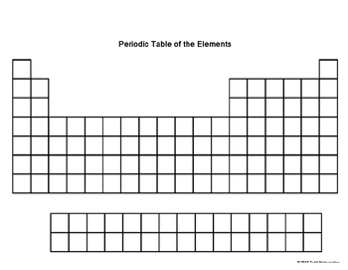

Skip a few …

Using the pattern above, determine how many valence electrons each of the elements below has.

1. ________ hydrogen
2. ________ nitrogen
3. ________ neon
4. ________ magnesium
5. ________ sodium
6. ________ aluminum
7. ________ silicon
8. ________ chlorine
9. ________ oxygen
10. ________ carbon

**Part 3: Charges**

Similar to the trend in valence electrons, all elements in the same column have the same charge. Using your notes, write above each column what the charge of the group is. Groups 1 and 2 have been done for you. (You can skip the transition metals and group 14!)

+1

+2



X

Skip a few …

Using the pattern above, determine the charge each of these elements form when they become ions.

1. ________ hydrogen
2. ________ nitrogen
3. ________ neon
4. ________ magnesium
5. ________ sodium
6. ________ aluminum
7. ________ calcium
8. ________ chlorine
9. ________ oxygen
10. ________ sulfur

**Part 4: Electronegativity**

Electronegativity will be an important concept in bonding. It is defined as how good an element is at pulling on another atom’s electrons.

On the periodic table below, draw arrows to show which two directions (up or down, left or right) that electronegativity increases.



Using the pattern above, determine which of the two elements listed is more electronegative in each pair.

1. F or O
2. N or P
3. Li or Be
4. Mg or Ca
5. Si or N
6. S or Sr
7. As or Cl
8. F or Ne