Making Accurate Measurements

Look at the rulers below. Estimate the length of the line for each one.

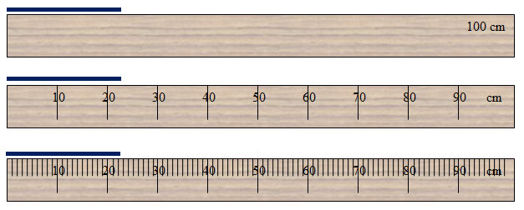

Which ruler gives you the most confidence in your measurement? Why?

Ruler A estimation: 30 cm, Ruler B: 23 cm, Ruler C: 22.4 cm – answers will vary

When making measurements, we must be careful about the number of decimal points to keep in our measurements. Here are the general rules:

1. Look at the smallest marking on the measurement tool. (Is it 5? 1? 0.1?) Write your measurement with this many decimal points to start.
2. Now add an estimate digit. If it is right on the line, write 0. If it’s in between, write 5 (or whatever it looks closes to).
3. Never drop zeros at the end of the number! If it is right on the line for 4.5 cm, write 4.50 centimeters. This helps to keep our measurements more precise!

**Practice:**

1. On the ruler shown below, please write the measurements for the spots marked. Please use correct significant figures and units! (This is a centimeter ruler)

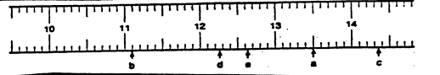

1. ____13.50 cm________
2. _____11.10 cm_______
3. _____14.35 cm_______
4. ____12.25 cm_______
5. ____12.62 cm_______

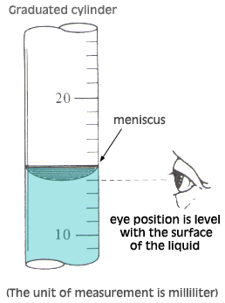**Measuring Volume**

When measuring on a graduated cylinder we want to measure to the bottom of the meniscus. The meniscus is the curve of the liquid at the top of the liquid level. To appropriately read liquid volumes, get eye level with the meniscus before measuring!

(see example to the right) What volume would this measure? __14.0 mL__

Don’t forget to add your estimation digit to the end of your number!

1. On the following graduated cylinders, please find the volume of the liquids. Please use the correct significant figures and units! (The cylinders measure in milliliters)

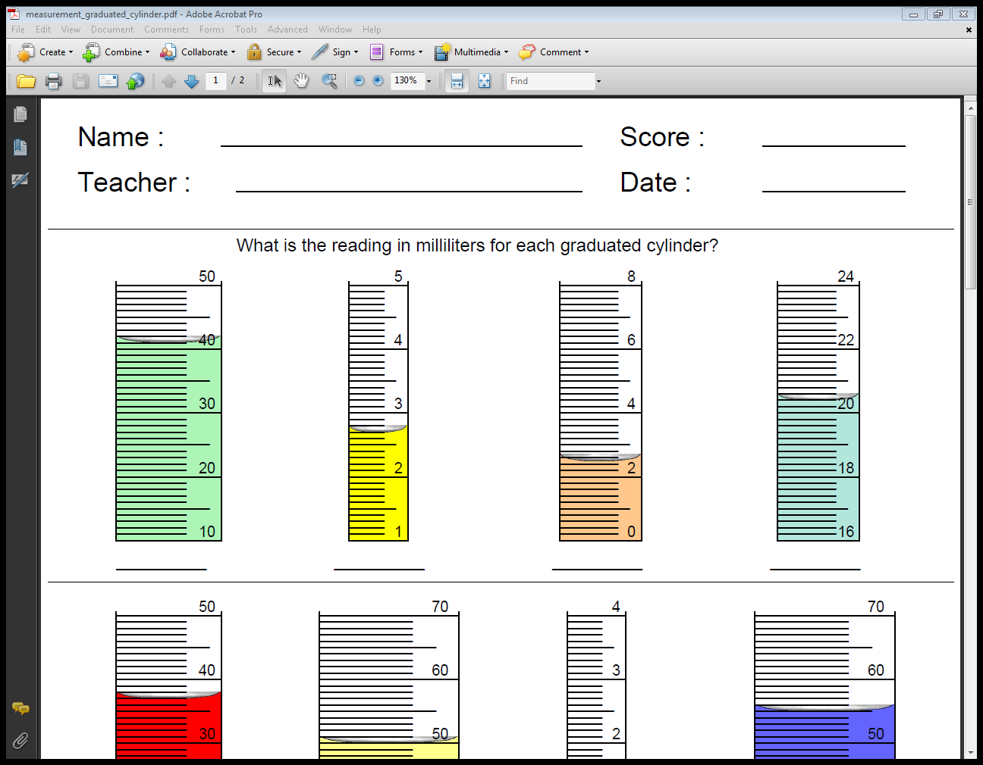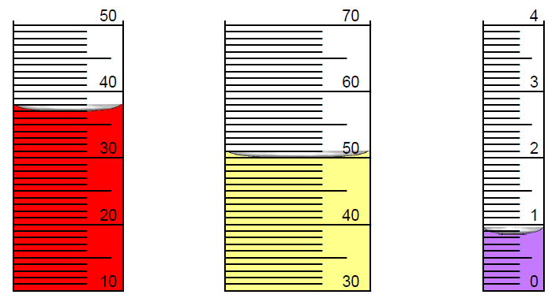

_41.1mL__ _2.70mL___ _skip_ __skip__ 37.0mL__ _49.9mL___ __0.85mL_

**Temperature**

Measuring temperature is the same as measuring length. The main thing to be careful of is the scale—remember that temperatures can be negative!

1. Record the following temperatures using the correct units and significant figures. (These thermometers measure in degrees Celsius!)

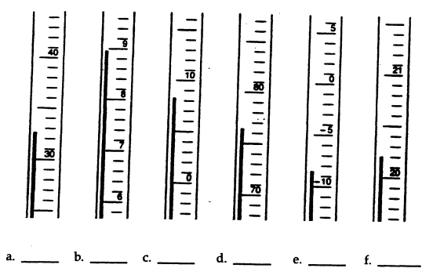

1. 32.5°C b. SKIP c. 8.2°C d. 76.5°C e. -8.4°C f. 22.0°C