Name: _______________________________________________ Date: _________________________ Period: ________

Dimensional Analysis, Measurements & Significant Figures Practice

Learning Targets 1.1, 1.2, 1.4

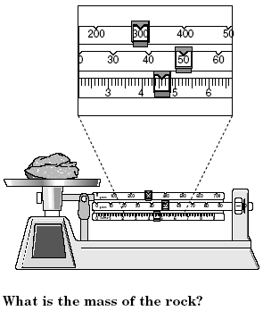

1. Use the triple beam balance to the right to answer the following questions.
   1. What’s the mass of the stone (in grams)? _________
   2. Convert the mass of the stone from grams to pounds. (Round appropriately and include units)

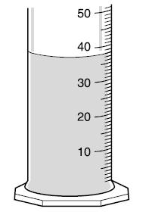

1. Use the graduated cylinder to the left to answer the following questions.
   1. How much water do you have in milliliters? __________
   2. How much water do you have in liters? (Round appropriately and include units)
2. Identify the number of sig figs in the following amounts.
   1. 8.7050 b. 670100 c. 0.0045 d. 0.10
3. Solve the problems and round appropriately using the rules of significant figures.
   1. 45.0 x 0.07 =
   2. 6.62 ÷ 20 =
   3. 4.5 + 5.60 =
   4. 870 – 100 =