Name: ____________________________________________ Date: ______________________________ Period: ______

Measurements & Doubt (LT 1.4)

Making Measurements to the Correct Number of Significant Digits

**What would you say is the temperature being registered by each thermometer in °C? Remember: Doubt!**

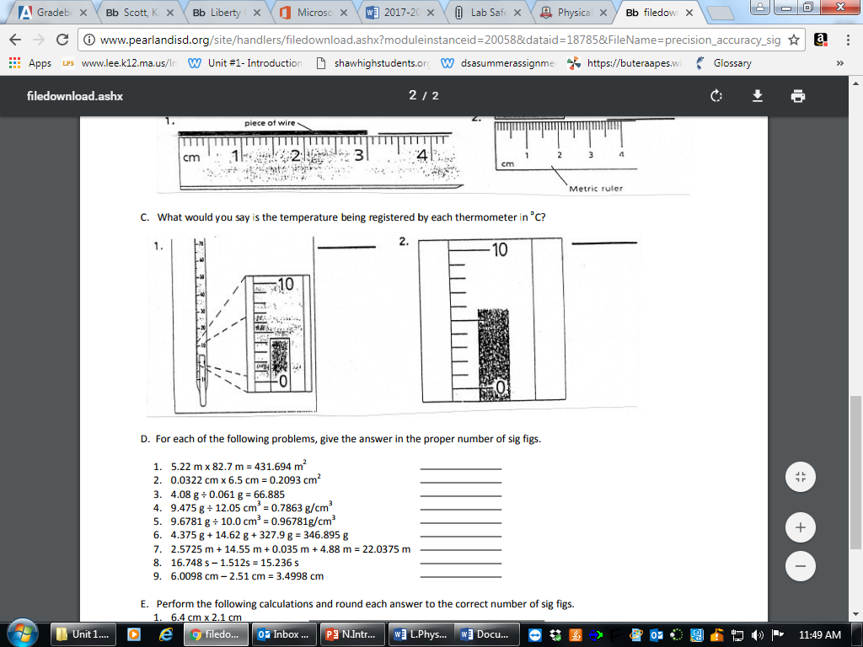

**How many fluid ounces are in each of the following beakers**?

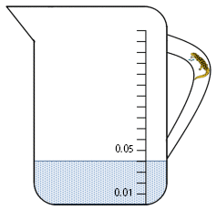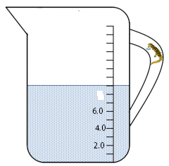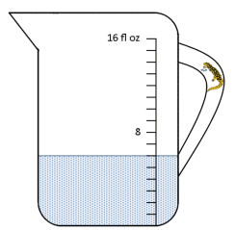

3. _________

4. ________

5. ________

**Using correct significant digits, make the following measurements. All measurements are in centimeters (cm).**

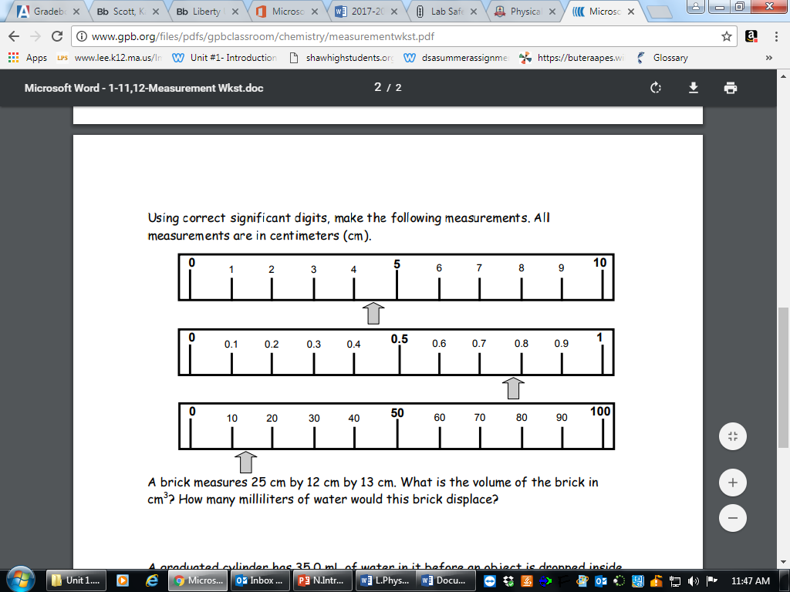

6. ___________

7. ___________

8. ___________

**Read the following triple beam scales and determine the masses. Triple Beam Balances measure in grams.**

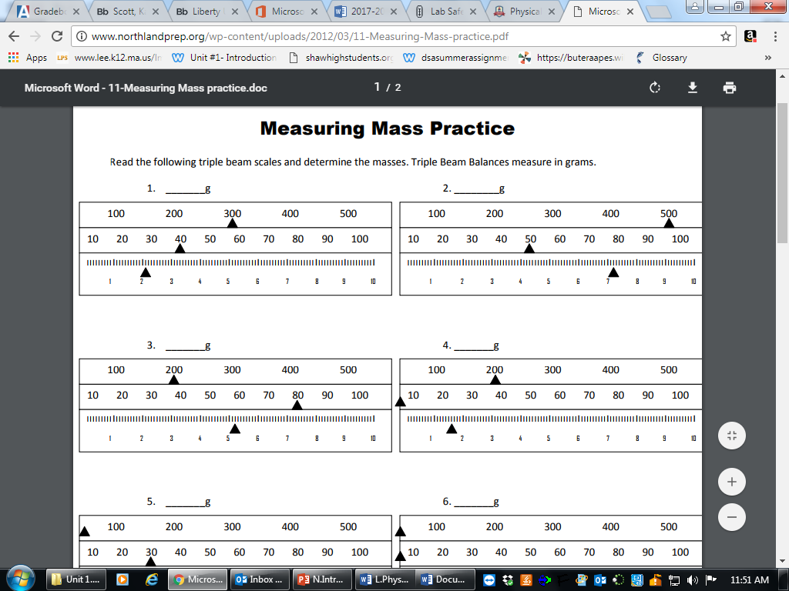

9. ____________________ 10. ____________________



11. ____________________ 12. ____________________

**How many milliliters are in each of the following graduated cylinders?**

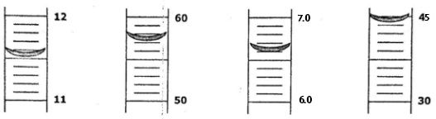

13. __________ 14. __________ 15. __________ 16. __________

