Name: _________ANSWER KEY________________________ Date: ______________________________ Period: ______

Measurements & Doubt (LT 1.4)

Making Measurements to the Correct Number of Significant Digits

**What would you say is the temperature being registered by each thermometer in °C? Remember: Doubt!**

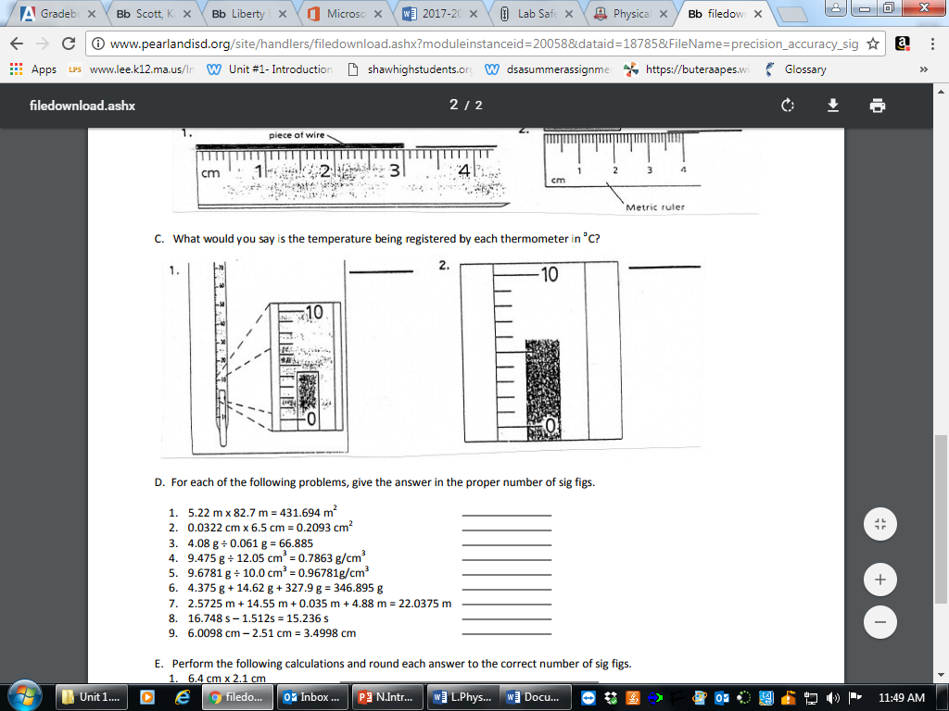 1. 4.4 °C 2. 5.8 °C

**How many fluid ounces are in each of the following beakers**?

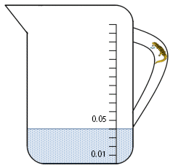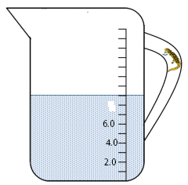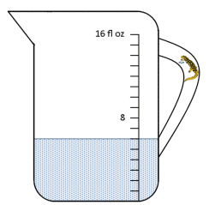

3. 0.041 fl oz_

4. __8.0 fl oz_

5. _6.0 fl oz__

**Using correct significant digits, make the following measurements. All measurements are in centimeters (cm).**

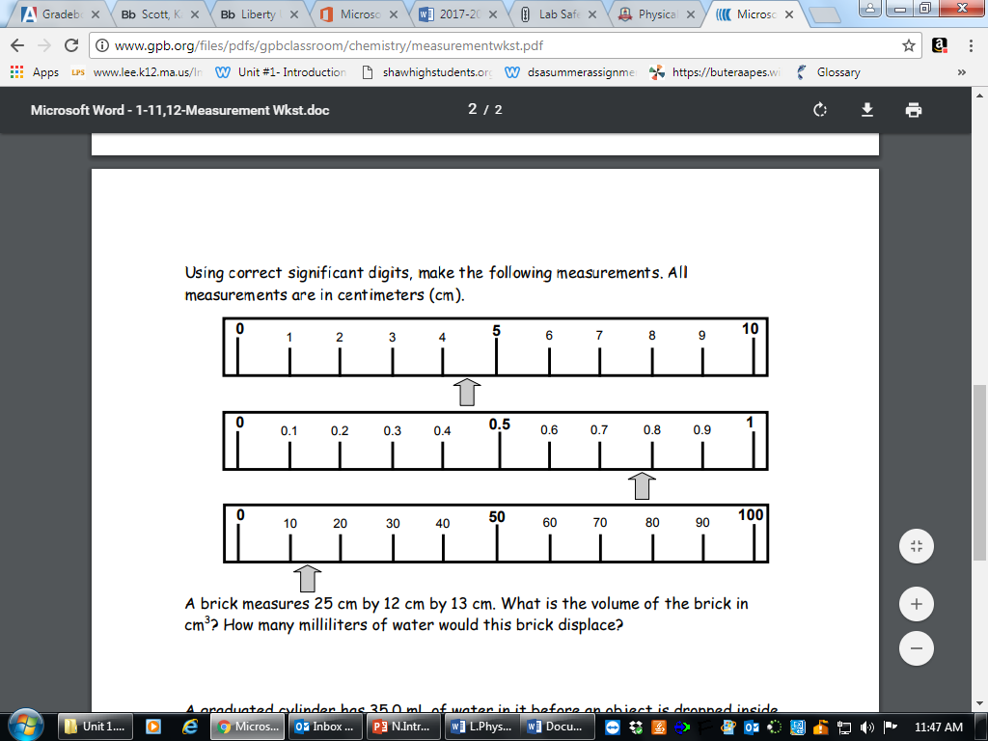

6. __4.4 cm_____

7. _0.78 cm___

8. __13 cm___

**Read the following triple beam scales and determine the masses. Triple Beam Balances measure in grams.**

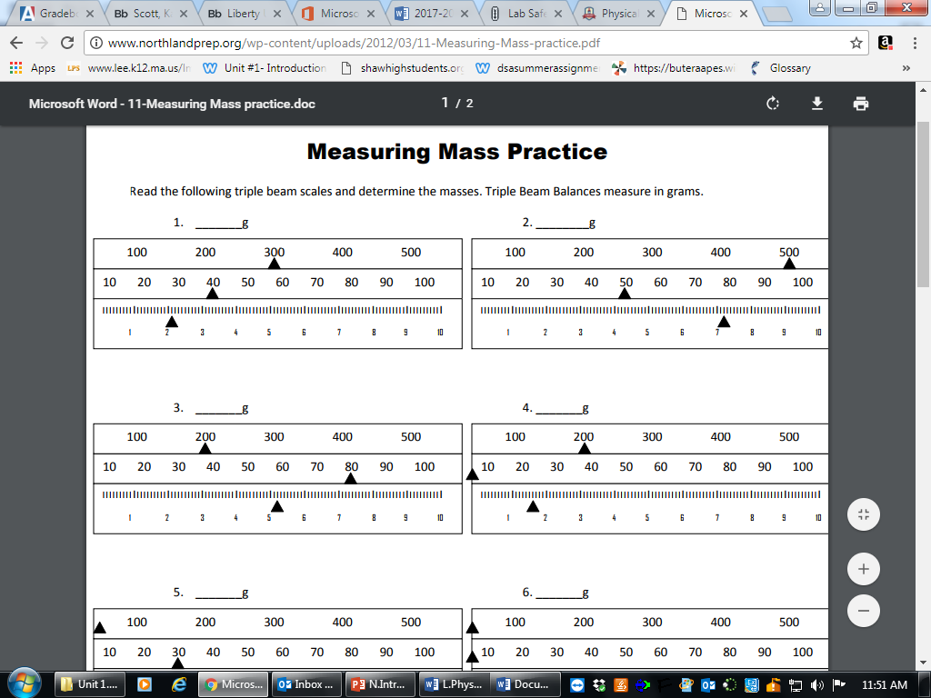

9. ____342.11 g____ 10. ___557.20 g________



11. ____285.18 g_________ 12. ____201.75 g_______

**How many milliliters are in each of the following graduated cylinders?**

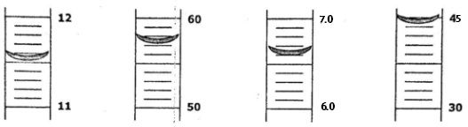

13. _11.52 mL__ 14. __57.3 mL___ 15. __6.61 mL____ 16. __SKIP___

