Name: KEY_______________________________ Date: _____________________________ Period: _______

Lewis Dot Structure Practice #2

1. Determine the bond type (I, C, M) between each of the following atoms.

Mg and P ______I_____________ Si and O _______C____________

H and P ______C_____________ Cr and F _______I____________

1. Determine if the following bonds are ionic, polar covalent or nonpolar covalent using ΔEN.

A bond is ionic if the ΔEN is above 2.1, a bond is NPC if the ΔEN is below 0.5, and it’s PC if the ΔEN is between 0.5 and 2.1.

Ba + S |0.89 – 2.58| = 1.69 🡪 PC C + O |2.55 – 3.44| = 0.89 🡪 PC

H + F |2.10 – 3.98| = 1.88 🡪 PC Se + S |2.55 – 2.58| = 0.03 🡪 NPC

1. Complete the following chart.

|  |  |  |  |
| --- | --- | --- | --- |
| **Element** | **Total # of electrons** | **# of valence electrons** | **Lewis Dot diagram** |
| Potassium | 15 | 1 | C:\Users\limm\AppData\Local\Microsoft\Windows\INetCache\Content.MSO\A008DC2A.tmp |
| Nitrogen | 7 | 5 | C:\Users\limm\AppData\Local\Microsoft\Windows\INetCache\Content.MSO\C441D5C8.tmp |
| Carbon | 6 | 4 | C:\Users\limm\AppData\Local\Microsoft\Windows\INetCache\Content.MSO\F4236716.tmp |
| Beryllium | 4 | 2 |  |
| Neon | 10 | 8 | C:\Users\limm\AppData\Local\Microsoft\Windows\INetCache\Content.MSO\2CF93820.tmp |
| Sulfur | 16 | 6 | C:\Users\limm\AppData\Local\Microsoft\Windows\INetCache\Content.MSO\67CAF32E.tmp |

1. Draw the lewis structure for each of the molecules below – use your steps from your notes!! ☺

|  |  |
| --- | --- |
| **a.** NCl3  C:\Users\limm\AppData\Local\Microsoft\Windows\INetCache\Content.MSO\C888776C.tmp | **b.** SO2 (Expanded octet exception)  C:\Users\limm\AppData\Local\Microsoft\Windows\INetCache\Content.MSO\40BB0C5A.tmp |
| **c.** H2S  C:\Users\limm\AppData\Local\Microsoft\Windows\INetCache\Content.MSO\BDB4E578.tmp | **d.** SO3 (Expanded octet exception)  C:\Users\limm\AppData\Local\Microsoft\Windows\INetCache\Content.MSO\393C0246.tmp |
| **e.** CI4 | **f.** NH4+1  C:\Users\limm\AppData\Local\Microsoft\Windows\INetCache\Content.MSO\E0BB40F2.tmp |
|  |  |

**g**. CH3CH3 **h.** PCl5 (Expanded octet exception)

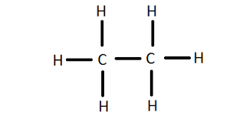 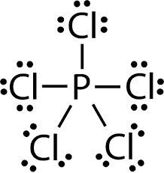

|  |  |
| --- | --- |
| **i.** CH2F2  C:\Users\limm\AppData\Local\Microsoft\Windows\INetCache\Content.MSO\961A088A.tmp | **j.** CO3-2 |

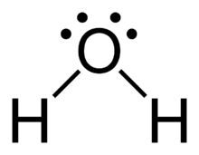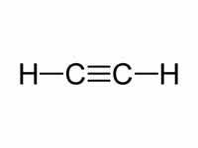**k**. C2H2 **l.** H2O