Name: ___________ANSWER KEY______________________ Date: ____________________________ Period: ________

Lewis Structures & Polarity Practice Worksheet

Drawing Lewis Structures – The Steps

- Count all the valence electrons.
- Determine the Central Atom (put a * next to it)
- Carbon or the atom with the lowest electronegativity
- Bond terminal (outside) atoms with a single bond (one line)
- Update Electron count (each bond is 2 electrons)
- Add remaining electrons as lone pairs (start with the outside elements and work your way inside)
- Check for octets (is everyone happy?) If not, shift the lone pairs to make multiple bonds.

Example: Draw the structure for CH₂Cl₂

- C = 4 electrons 2. Carbon will be the central atom
2H = 2(1) electrons
2Cl = 2(7) electrons C*
20 electrons total

- Attach Hs and Cls with single bonds around C 4. 20 electrons – 8 electrons = 12 electrons

H

Cl C Cl

H

- Add remaining electrons to Cl first (DON’T ADD ANY TO H, H is already happy! )

H

Cl C Cl 6. Is everyone happy? Yes!

H

Formula | Lewis Structure | Polar/Nonpolar around Central Atom?
HBr | 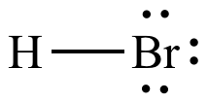 | Polar
CH₃F | 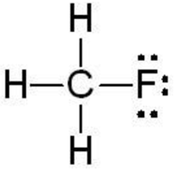 | Polar
PBr₃ | 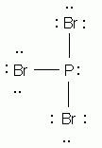 | Polar
PO₄⁻³ |  | Nonpolar
H₂O | 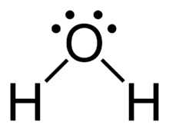 | Polar
CO₂ | 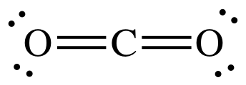 | Nonpolar
H₂O₂ | 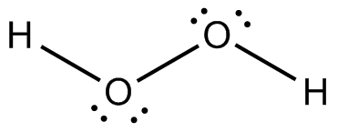  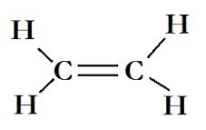 | Polar
C₂H₄ |  | Polar
N₂ |  | Nonpolar
BF₃ |  | Nonpolar

