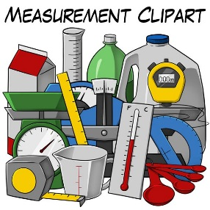Name: ______________________________________________________ Date: ________________ Period: _________

Unit Conversions by Dimensional Analysis

Changing the “Language” measurements are written in

**Before Beginning,** please sort your cards into 4 piles: 4 shape cards, 4 fruit cards, 5 length cards, and 3 mass cards.

**Dimensional Analysis** is a method of converting units where we multiply by a conversion factor and cancel units. There are three key things we must understand before beginning:

1. An conversion factor, such as 12 inches = 1 foot, can be written as the fraction $\frac{12 inches}{1 foot}or\frac{1 foot}{12 inches}$
2. Anything divided by itself is 1, so when we divide two equivalent things they are equal to 1
3. Multiplying a number by a conversion factor does not change the quantity, just the units (think of this like translating from one language to another, it’s the same thing but written a different way!)

| Given (with units) x | Conversion | = Answer (with new units) |
| --- | --- | --- |
|  | Factor |  |

Dimensional analysis set up:

**Part 1: Units Only**

Find the “shape” cards. These have conversion factors written as fractions—they are flipped on the reverse side of the card. Your equivalence factors are shown below:

Circle = square

Square = oval

Circle = star

Circle = rectangle

| Circle |  | = Square |
| --- | --- | --- |
|  |  |  |

| Square |  | = Oval |
| --- | --- | --- |
|  |  |  |

For each of the following, find the cards that would get you from the starting unit to the desired unit. Fill in the grid with the correct units, then cross out any units that cancel.

| Star |  |  | = Square |
| --- | --- | --- | --- |
|  |  |  |  |

| Rectangle |  |  |  | = Oval |
| --- | --- | --- | --- | --- |
|  |  |  |  |  |

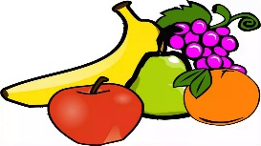**Part 2: Let’s Make a Fruit Salad!** Adding in the numbers.

Put the 4 shape cards back into the bag, then get the 4 fruit cards ready. The idea here is to figure out how much of each fruit you need to make a fruit salad! This time, there are numbers!

*Note! Only the UNITS cancel out for these! The numbers must be used to calculate…*

*We MULTIPLY the given by the numbers on top and DIVIDE by all the numbers on the bottom.*

For each of the following, find the cards that would get you from the starting unit to the desired unit. Fill in the grid with the correct units, then cross out any units that cancel. Finally, calculate the answer!

| 5 Kiwi |  | = _____ Berries |
| --- | --- | --- |
|  |  |  |

| 10 Apples |  | = _____ Oranges |
| --- | --- | --- |
|  |  |  |

*Continued…*

| 3 Oranges |  |  | = _____ Berries |
| --- | --- | --- | --- |
|  |  |  |  |

| 3 Apples |  |  |  | = ____ Bananas |
| --- | --- | --- | --- | --- |
|  |  |  |  |  |

**Part 3: Converting Mass**

Put the 4 fruit cards away and take out the 3 mass conversions. The conversion factors are given below:

1 pound (lb) = 16 ounces (oz) 1 kilograms (kg) = 2.2046 pounds (lbs) 1 kilograms (kg) = 1000 grams (g)

We will now perform some actual unit conversions!

| 10.5 lbs |  | = __________ kg |
| --- | --- | --- |
|  |  |  |

| 457 g |  |  |  | = ___________ oz |
| --- | --- | --- | --- | --- |
|  |  |  |  |  |

For this problem, fill in the given and the end units yourself! How many grams in 14 lbs?

|  |  |  |  |
| --- | --- | --- | --- |
|  |  |  |  |

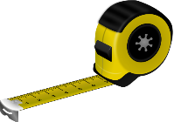**Part 4: Converting Length**

Now that you have the hang of the pattern, you are going to use the length cards to practice some conversions. Put away the 3 mass cards and take out the 5 length cards. The conversion factors are:

1 meter (m) = 1.094 yards (yds)

1000 meters (m) = 1 kilometer (km)

1 kilometer (km) = 0.6215 miles (mi)

1 mile (mi) = 5280 feet (ft)

3 feet (ft) = 1 yard (yd)

Practice problems: Underline the given and circle the want before performing the calculation! SHOW ALL WORK!

1. How many yards are in 18 feet?
2. How many feet are in 3 miles?
3. How many meters are in 0.6215 miles?
4. How many meters are in 25 feet?

**Wrap Up Questions**

1. 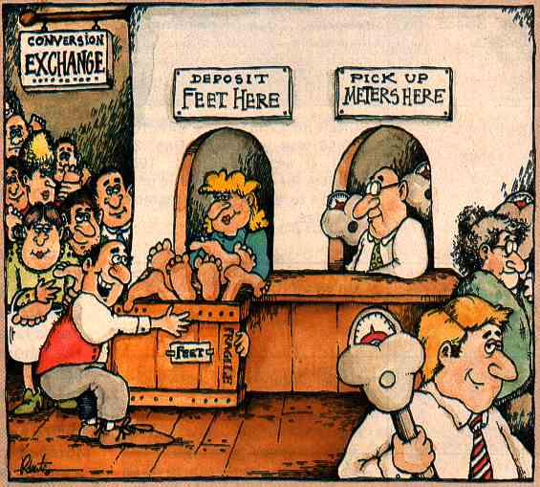For volume, there are 15 mL in one tablespoon (tbsp). Write the two conversion factors (“cards”) you could make with this.
2. Knowing that conversions, how many mL are there in 3 cups? Show your work!
3. Challenge: The school year is 180 days long. How many seconds is that?