Name: ______________________________________________________ Date: ____________________ Period: ______

**Conservation of Mass Introduction**

**Background Information**

Antoine Lavoisier was a French chemist who did most of his work between 1772-1786. He built a magnificent laboratory in Paris, France and invited scientists from around the world to come and visit. Lavoisier conducted numerous controlled experiments. He published two textbooks that helped organize chemistry into a comprehensible science. Based on his contributions to chemistry, Lavoisier is commonly known as the Father of Modern Chemistry.

Lavoisier’s most famous experiments involved the combustion (burning) of substances such as phosphorus, sulfur, and mercury. He proposed that air is composed of two parts, one of which combines with metals to form new products. This part was later named oxygen. Lavoisier believed that when a substance burns, oxygen from air combines with that substance to form a new substance.

**Objective: Analyze the data for each of the following experiments and create a definition for Conservation of Mass.**

Experiment #1

Reactant(s) Product(s)

Magnesium + Oxygen 🡪 Magnesium Oxide

48.6 g + 32.0 g 🡪 80.6 g

1. What is the mass of each reactant? ________ + ________
2. What is the total mass of the reactants (add them together)? ________
3. What is the mass of the product? ________

Experiment #2

Reactant(s) Product(s)

Potassium Iodide + Lead Nitrate 🡪 Potassium Nitrate + Lead Iodide

14.5 g + 28.6 g 10.2 g + 32.9 g

1. What is the total mass of the reactants side? ___________
2. What is the total mass of the products side? ___________
3. All experiments follow the “Law of Conservation of Mass.” Write your initial definition for the Law of Conservation of Mass? (aka what do you think it means?):

____________________________________________________________________________________________________________________________________________________________________________________________________________________________________________________________

Experiment #3

Reactant(s) Product(s)

Barium + Oxygen 🡪 Barium Oxide

4.5 g + 5.2 g 8.2 g

1. Does the experimental data from #3 (above) support or refute your Law of Conservation of Mass you defined above? Cite specific evidence.

____________________________________________________________________________________________________________________________________________________________________________________________________________________________________________________________

Lavoisier’s experiments (discussed in the background information) showed that the new product weighed more than the original substance by a mass equal to the amount of oxygen that reacted with the substance. These experiments led to what is currently known as The Law of Conservation of Mass. *This law states that mass can neither be created nor destroyed. It can only be converted from one form to another.* So the mass on the reactants side of a chemical equation needs to be equal to the mass on the products side.Initially, Lavoisier’s conclusions were not accepted by the scientific world but they eventually led to a revolution in chemical thought. His work ultimately led to the basis of Dalton’s Atomic Theory.

Based on the Law of Conservation of Mass, predict the missing masses of the following experiments.

Experiment #4

1. 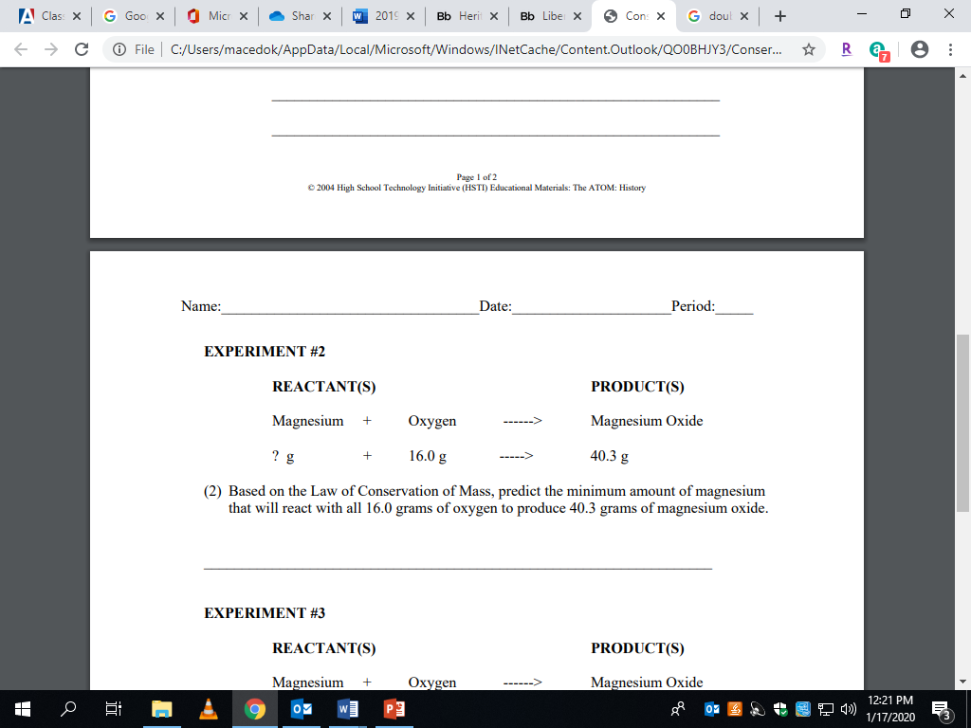The mass of magnesium should be

____________.

Experiment #5

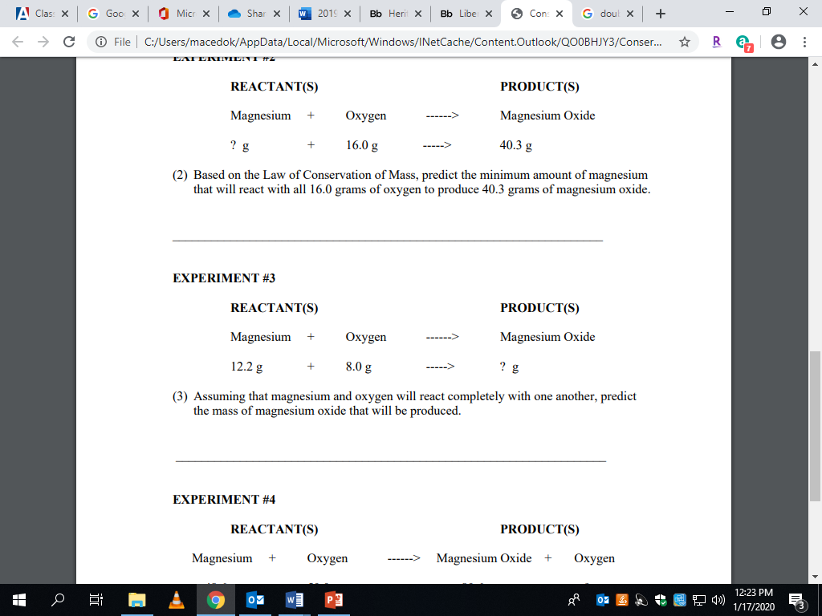

1. The mass of magnesium oxide should be ____________.

Experiment #6

1. 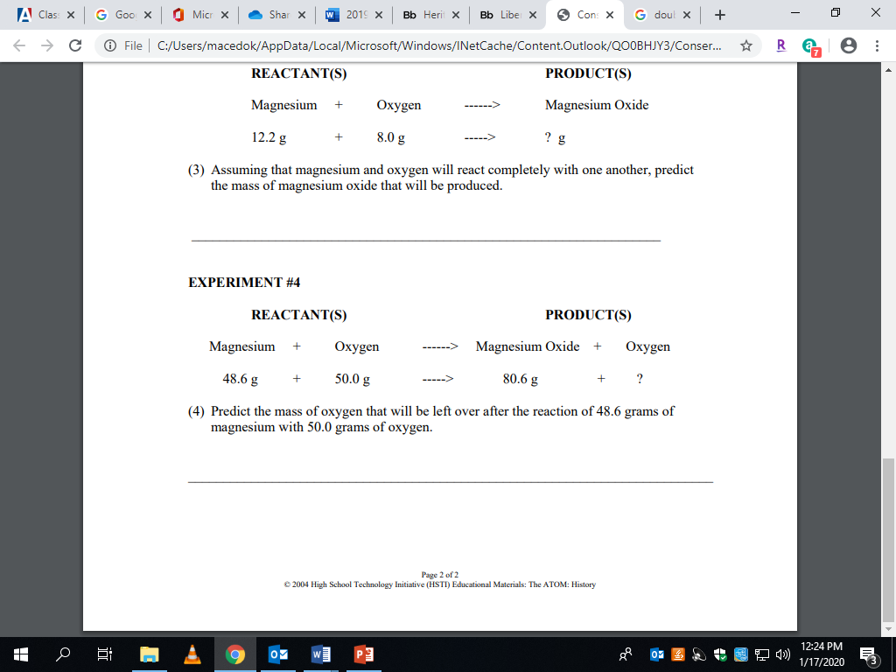The mass of oxygen left over should be ___________.

**A preview of the lab next class…**

Baking Soda + Vinegar 🡪 Products

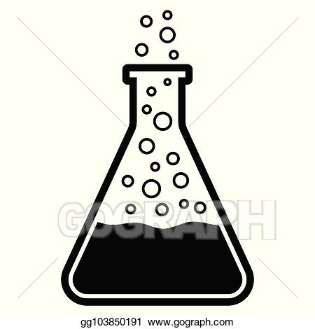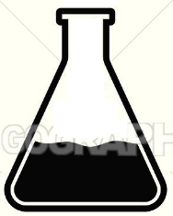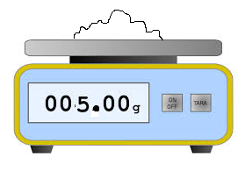

5.0 grams + 6.0 grams 🡪 9.7 grams

What do you notice about the reaction? Why is it currently “not following” the law of conservation of mass? What improvements could you make to the reaction set-up so as to conserve (keep and not lose) all of the mass from the reactants?

______________________________________________________________________________________________________________________________________________________________________________________________________________________________________________________________________________