Name: _________________________________________________ Date: _______________________ Period: ___________

[](https://www.google.com/url?sa=i&rct=j&q=&esrc=s&frm=1&source=images&cd=&cad=rja&docid=5twgjv4zCI4x7M&tbnid=Iq9TM5h2t_NfGM:&ved=0CAUQjRw&url=https://itunes.apple.com/us/app/its-a-small-world/id484670255?mt=8&ei=pwocUdqmI4LJigKQuIHgCg&bvm=bv.42452523,d.cGE&psig=AFQjCNFvvUPSmYfxQm-T-As-MpXMkMMnMg&ust=1360878621629753)

Small Stuff in the Small World – Introducing Ions

*How do we describe something we cannot see? It helps to use models. The first theory of the atom was made by the Greek philosopher Democritus. It took almost 2000 years before the next theory…Dalton’s… which occurred around the 1700’s.* ***More info in your textbook, page 101-108.***

**Objective:** Understand which subatomic particles are added or removed when an ion is formed. Recognize how chemical symbols communicate the number of subatomic particles that have been added or removed.

**Figure 4: Atoms vs Ions**

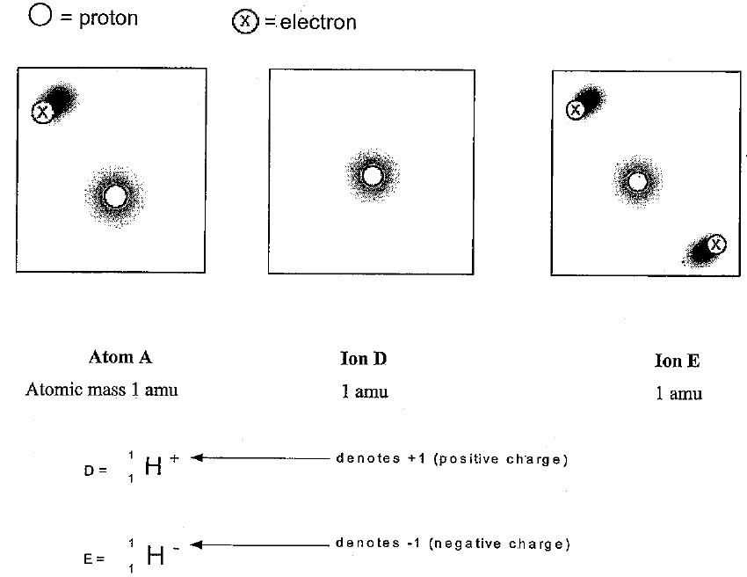**1.** In atom A how many protons are

there? ____ Ion D? ____ Ion E? ____

**2.** In atom A how many electrons are

there? ____ Ion D? ____ Ion E? ____

**3.** How are the 3 diagrams the same?

**4.** How are they different?

**5.** One diagram is listed as an atom; the other two are listed as ions. What makes an ion different from an atom?

1. How does the atomic mass change when an atom becomes an ion?
2. Is the charge of an ion positive or negative (circle one) when there are more electrons than protons?
3. Is the charge of an ion positive or negative (circle one) when there are fewer electrons than protons?

**Cations are positive ions.**

**Anions are negative ions.**

**Atoms are neutral and have equal #s of electrons and protons.**

1. Classify each row in Table 1 as a cation, anion or atom.

|  |  |  |  |
| --- | --- | --- | --- |
| # neutrons | # electrons | # protons | Classification  (cation, anion, atom) |
| 9 | 10 | 9 |  |
| 13 | 12 | 12 |  |
| 32 | 28 | 30 |  |
| 12 | 10 | 11 |  |
| 5 | 4 | 4 |  |
| 20 | 18 | 19 |  |
| 16 | 18 | 16 |  |
| 33 | 28 | 29 |  |

When an electron is added the

ion has a __________________ charge.

When an electron is lost the ion has a

___________________ charge.

**Atoms vs. Ions Review**

*The first one, Lithium atom & lithium ion, have been done for you as an example!*

**Cations:** Have a positive charge because they have lost electrons **Anions:** Have a negative charge because they have gained electrons

**Ion symbol:** To write the ion symbol 🡪 the atomic symbol with the charge written on the top right. *Examples:* **Ca2+**, **Zn2+**, **Ag1+**

|  |  |  |  |
| --- | --- | --- | --- |
| **Lithium atom** | **Lithium ion (+1)** | **Aluminum atom** | **Aluminum ion (+3)** |
| Atomic number: **3** | Atomic number: **3** | Atomic number: | Atomic number: |
| Mass number: **6.941** | Mass number: **6.941** | Mass number: | Mass number: |
| Protons: **3** | Protons: **3** | Protons: | Protons: |
| Neutrons: **4** | Neutrons: **4** | Neutrons: | Neutrons: |
| Electrons: **3** | Electrons: **2** | Electrons: | Electrons: |
| Cation/Anion: **cation** | Ion symbol: **Li+** | Cation/Anion: | Ion symbol: |
| **Nitrogen atom** | **Nitrogen ion (-3)** | **Sulfur atom** | **Sulfur ion (-2)** |
| Atomic number: | Atomic number: | Atomic number: | Atomic number: |
| Mass number: | Mass number: | Mass number: | Mass number: |
| Protons: | Protons: | Protons: | Protons: |
| Neutrons: | Neutrons: | Neutrons: | Neutrons: |
| Electrons: | Electrons: | Electrons: | Electrons: |
| Cation/Anion: | Ion symbol: | Cation/Anion: | Ion symbol: |
| **Fluorine atom** | **Fluorine ion (-1)** | **Calcium atom** | **Calcium ion (+2)** |
| Atomic number: | Atomic number: | Atomic number: | Atomic number: |
| Mass number: | Mass number: | Mass number: | Mass number: |
| Protons: | Protons: | Protons: | Protons: |
| Neutrons: | Neutrons: | Neutrons: | Neutrons: |
| Electrons: | Electrons: | Electrons: | Electrons: |
| Cation/Anion: | Ion symbol: | Cation/Anion: | Ion symbol: |

**The charge on an ion will involve a number and a sign. The number will always be the number of electrons involved, e.g., loss of two electrons is +2. The sign will be positive if electrons, negatives, are lost and negative if electrons, negatives, are gained.**

Determine the charges on the following using the diagram above as a guide:

1. An atom having lost two electrons ________ 5. An atom having lost six electrons ________
2. An atom having gained one electron ________ 6. An atom having gained three electrons ________
3. An atom having lost five electrons ________ 7. An atom having gained two electrons ________
4. An atom having lost one electron ________ 8. An atom having gained four electrons ________

**For the questions below determine if the particle that is described in an atom or an ion.**

In the space that says, “charge”, write either “positive”, “negative”, or “no charge”.

Then indicate whether the particle is an “atom” or an “ion”.

1. A particle of oxygen that contains 8 protons and 8 electrons. Charge ______ Atom or ion? _____

10. A particle of fluorine that contains 9 protons and 10 electrons. Charge ______ Atom or ion? ______

11. A particle of calcium that contains 20 protons and 18 electrons. Charge ______ Atom or ion? ______

12. A particle of uranium that contains 92 protons and 88 electrons. Charge ______ Atom or ion? ______