Name: ___________ANSWER KEY_____________________ Date: ____________________________ Period: _______

**Summative 5.3 Study Guide**

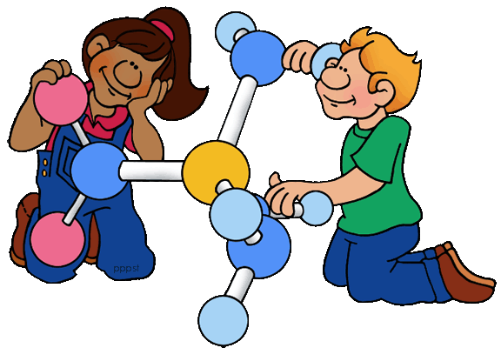

**Chemical Bonding Concepts**

* Define and recognize cation vs anion, relate to metal vs nonmetal
* Distinguish between chemical formulas, ion symbols, polyatomic ions, and chemical nomenclature
* Determine ion charges using periodic table
* Know the 9 Polyatomic ions
* Apply rules to write ionic compound chemical formulas – cross over and down, roman numerals, simplifying, polyatomic ions.

**Review/Practice Questions**

1. Identify whether the following are made up of ionic (I) or covalent (C) or metallic (M) bonds

a. sodium chloride b. aluminum foil c. iron(II) oxide d. CH4

Ionic Metallic Ionic Covalent

1. Identify if the following are anions or cations. Draw their Lewis Dot Diagram for the ion.

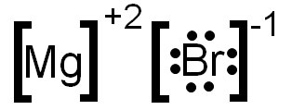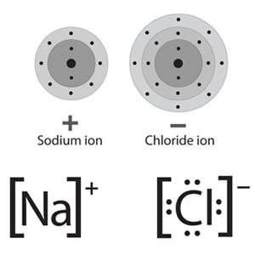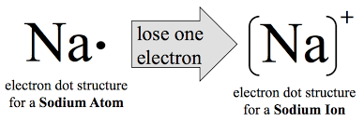

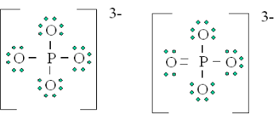a. Na+ cation b. Cl- anion c. Mg+2 cation

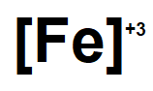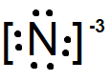

d. N-3 anion e. Fe+3 cation f. PO43- anion

1. Write the symbol and charge of the following ions:
2. Nitride ion N -3 d. Nitrate ion NO3 - g. Manganese (II) ion Mn +2
3. Calcium ion Ca +2 e. Bromide ion Br - h. Carbonate ion CO3 -2
4. Iron (III) ion Fe +3 f. Zinc ion Zn +2 i. Phosphide ion P -3
5. Write the chemical formula for each ionic compound.

|  |  |  |  |  |  |
| --- | --- | --- | --- | --- | --- |
| Ion | P3- | CO32- | OH- | Phosphate Ion | Selenide ion |
| Al3+ | AlP | Al2(CO3)3 | Al(OH)3 | AlPO4 | Al2Se3 |
| Nickel (I) Ion | Ni3P | Ni2CO3 | NiOH | Ni3PO4 | Ni2Se |

1. Write the chemical formula for the following ionic compounds:
2. ammonium nitrate NH4+ NO3- 🡪 NH4NO3 i. hydrogen carbonate H+ CO3-2 🡪 H2CO3
3. calcium hydroxide Ca+2 OH-1 🡪 Ca(OH)2 j. silver oxide Ag+1 O-2 🡪 Ag2O
4. sodium phosphide Na+1 P-3 🡪 Na3P k. iron (III) sulfide Fe+3 S-2 🡪 Fe2S3

1. zinc bromide Zn+2 Br-1 🡪 ZnBr2 l. lithium oxalate Li+1 C2O4-2 🡪 Li2C2O4
2. aluminum bicarbonate Al+3 HCO3-1 🡪 Al(HCO3)3 m. calcium cyanide Ca+2 CN-1 🡪 Ca(CN)2
3. strontium fluoride Sr+2 F-1 🡪 SrF2 n. ammonium nitride NH4+1 N-3 🡪 (NH4)3N
4. copper (II) chloride Cu+2 Cl-1 🡪 CuCl2 o. manganese (II) selenide Mn+2 S-2 🡪 MnS