**Summative 5.1, 5.2 Study Guide – Bond Properties, Lewis Structures & Polarity**

1. Classify the following compounds as ionic (I), covalent (C), metallic (M)

CaCl2 _______ CO2 _______ Ni _______

H2O _______ K2O _______ NaF _______ Fe _______ CH4 _______ SO3 _______ LiBr _______ MgO _______ P2O5 _______ HCl _______ KI _______ N2O3 _______

1. Identify whether the following are examples of Ionic - I, Covalent (Polar or Nonpolar) – PC or NPC, or Metallic Bonds - M.
   1. Also known as an electrolyte _________________________
   2. Has a low melting point _________________________
   3. Both bonded atoms have high electronegativities _________________________
   4. Electronegativity of first atom = 0.7, Electronegativity of second atom = 2.7 _______________
   5. Does not conduct electricity _________________________
   6. Electrons are shared unequally _________________________
   7. Also known as an alloy _________________________
   8. Electronegativity of first atom = 0.7, Electronegativity of second atom = 0.5 _______________
   9. Bond Diagram looks like _________________________
   10. Example molecule looks like _____________ k. Example molecule looks like ___________

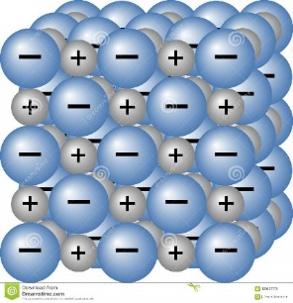 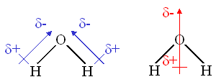

1. What is electronegativity?
2. How do electronegativity values help us determine the type of bond created?
3. For each of the following sets of elements, identify the element expected to be most electronegative (EN) and which is expected to be least electronegative (EN).
   1. K, Sc, Ca most EN= ________ least EN=________
   2. Br, F, At most EN= ________ least EN=________
   3. C, O, N most EN= ________ least EN=________
4. Draw the lewis dot diagram for the following elements:
   1. Na b. Cl c. He d. P e. Se

|  |  |  |  |
| --- | --- | --- | --- |
| **Molecule** | **Electronegativity Values** | **Difference in Electronegativity** | **Bond Type** |
| **H – Cl** | H: Cl: |  |  |
| **H – H** | H: H: |  |  |
| **H - I** | H: I: |  |  |
| **Cl - Cl** | Cl: Cl: |  |  |
| **C – O** | C: O: |  |  |

1. For each of the following molecules to the right, determine if it is covalent, polar covalent, or ionic. Show your work by listing the electronegativities of each element in the bond. (use the table below)

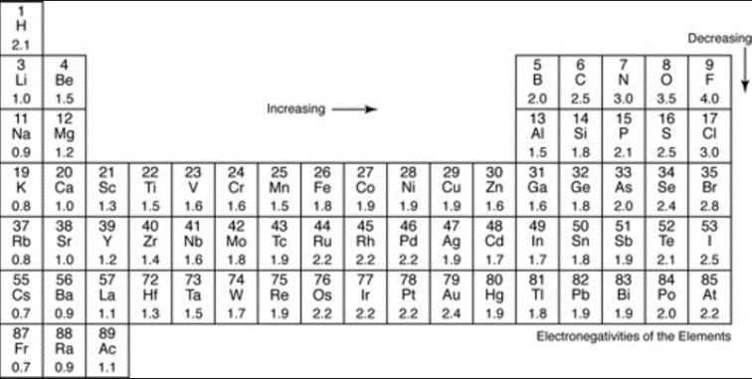

1. Draw Lewis Structures for the following molecules.

SF2 CO2 CBr4 PCl3

* 1. Which is more polar – CO2 or PCl3 – Why?

1. 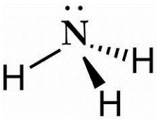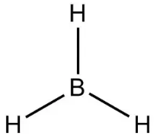For each of the following pairs of molecules, determine which is most polar and explain your reason for making this choice:
   1. boron trihydride (BH3) OR ammonia (NH3)

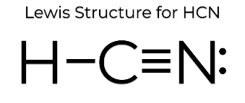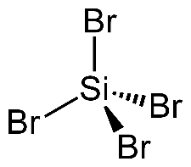

* 1. silicon tetrabromide (SiBr4) OR HCN

1. Which element(s) can have fewer than 8 and still be stable/happy? _____ _____ _____
2. Which element(s) can have more? _____ _____