Name: ____________ANSWER KEY_____________________ Date: ___________________________ Period: _______

**Summative 1.6, 2.1 and 2.2 – Study Guide**

Learning Target 1.6 – Systems and Energy Flow

1. Identify the systems and the surroundings in the following examples. Which way is the energy flowing? (Draw a diagram using arrows to represent the energy flow).
   1. When a small quantity of ammonium chloride (NH4Cl) is dissolved in water in a test tube, the tube becomes colder than before.

System: NH4Cl

Surrounding: Water and test tube

Energy (heat) is flowing from the surrounding/water into the system/NH4Cl

* 1. Burning a log in the fireplace to heat up the living room.

System: Log on fire

Surrounding: Living room

Energy is flowing from system/burning log into the surrounding/room.

* 1. A hot pack is made up of two bags (one contains water and one contains calcium chloride).

When the calcium chloride reacts with the water, it gives off heat.

System: Bag of water and Bag of calcium chloride

Surrounding: Hands (whatever the hot pack is heating up)

Energy (heat) is flowing from the system/bags into the surroundings/hands

* 1. Adding ice to a glass of soda will cool down the soda

System: Ice

Surrounding: Soda

Energy is flowing from the surrounding/soda into the system/ice (ice requires energy to melt)

1. Complete the following table by defining the types of energy and sorting the examples into the appropriate boxes.

|  |  |
| --- | --- |
| Kinetic Energy | Potential Energy |
| Definition: Moving Energy | Definition: Stored Energy |
| A student taking notes, Weasels weaseling | Cheetos in a bag, A glass of milk on a table, chemical energy, a skier at the top of a mountain, a bird in its nest at the top of a tree |

Examples to be sorted: Cheetos in a bag, A glass of milk on the table, Weasels weaseling, A student taking notes, chemical energy, a skier at the top of a mountain, a bird in its nest at the top of a tree

Learning Target 2.1 – Kinetic Molecular Theory

1. A substance at 10°C and a substance at 20°C are compared in a lab. Which has more energy? Why?

The substance at 20°C contains more energy because it has a higher temperature. Substances with higher temperatures contain more kinetic energy.

1. In the boxes below, draw the particles and movement for solids, liquids, gases (see Mrs. Macedo to have your drawings checked if you’d like). Which has the highest KE? Which has the largest spaces?

Gas

Liquid

Solid

Gases have the highest KE and the largest space between particles

1. Which state(s) of matter can change its shaped? Liquids and gases
2. Which state of matter is most easily compressed – why?

Gases can be easily compressed because there is a large amount of space between particles.

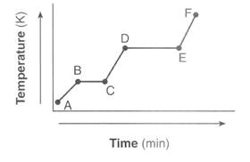Learning Target 2.2 – Heating and Cooling Curves

1. Use the heating curve to the right to answer the following questions:
   1. Label the states of matter on the graph.

A-B is solid, C-D is liquid, and E-F is gas

* 1. Label the phase changes on the graph.

B-C is melting, D-E evaporating/boiling

* 1. What is happening to the energy (KE & PE) at line BC?

KE is staying the same because temperature is constant, temperature is a measurement a kinetic energy. PE is rising, as the solid spread out more to a liquid.

* 1. What is happening to the energy at line DE?

KE is staying the same because temperature is constant. PE is rising because the particles are spreading out more.

1. Sketch the corresponding cooling curve for question 7. Label the states of matter, the phase changes, and discuss the changes in KE and PE along each line. (See Mrs. Macedo to have yours checked)

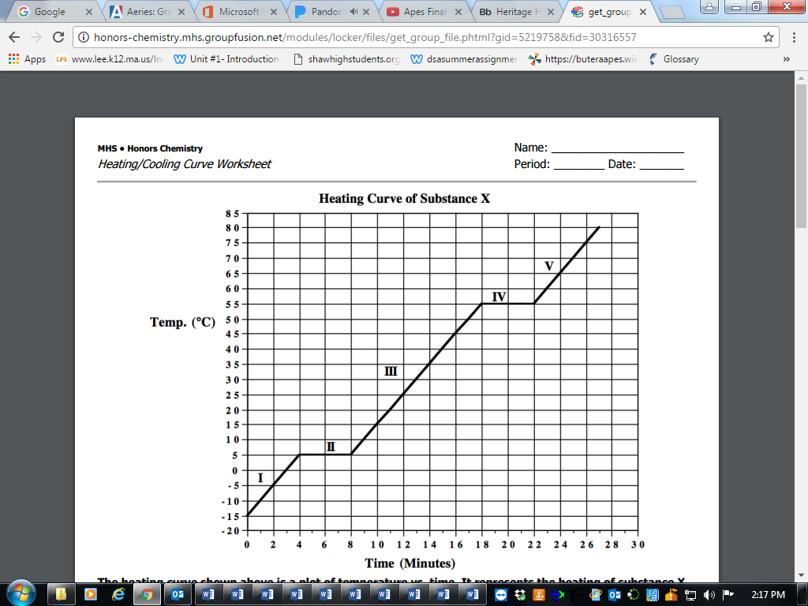

1. In what part of the curve would substance X have definite volume and shape? Part I
2. What part of the curve represents a mixed liquid/vapor phase? Part IV
3. What is the melting point of substance X? 5°C
4. In what part(s) of the curve would increasing kinetic energy be displayed? Parts I, III, and V because temperature is increasing.
5. What is happening to the potential energy in part IV? Potential energy is increasing

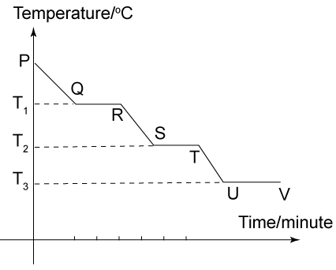

1. In what segment of the curve would substance Y have indefinite shape and definite volume? RS (liquid)
2. What is the freezing point of substance Y? T2
3. What is happening to the energy at segment RS? (Indicate what type of energy you are talking about) Kinetic energy is decreasing
4. What is happening to the energy at segment ST? (indicate what type of energy you are talking about) Kinetic energy is constant because temperature is not changing. PE is decreasing because energy is released.