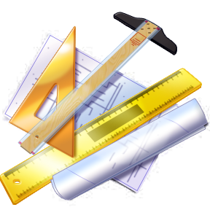
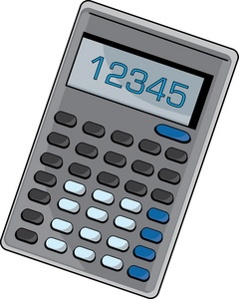
Name: _________________________
Period: ________________________
Date: _________________________
Summative 1.1, 1.2 Study Guide

Scientific Notation
Convert to scientific notation or standard form. Keep the number of significant figures the same as the given number.

- 3,456,320 ________________________ 5. 4.563 x 10⁻⁴ ________________________

- 0.0004322 ________________________ 6. 3.40 x 10¹ ________________________

- 102.0 ________________________ 7. 7.8322 x 10⁰ ________________________

- 20,100 ________________________ 8. 2.41 x 10⁵ ________________________

Significant Figures
Indicate the number of significant figures, and then round each to the number of significant figures specified.

Ex. 1.234 has 4 significant figures and, rounded to 2 significant figures, is 1.2

- 0.089 has ______ significant figures and, rounded to 1 significant figure, is _____________

- 10,700 has ______ significant figures and, rounded to 2 significant figures, is _____________

- 12,700.00 has ______ significant figures and, rounded to 1 significant figure, is _____________

- 0.0009880 has ______ significant figures and, rounded to 2 significant figures, is _____________

- 201,000 has ______ significant figures and, rounded to 2 significant figures, is _____________

Rounding
Report the unrounded answer in the first blank, and then round the final answer correctly in the second blank.

Unrounded Answer Rounded (Final) Answer

Ex. 134.8 + 27.67 = 162.47 162.5

- 206.5 + 4.002 = ______________ _______________

- 6.341 + 102.0 = ______________ _______________

- 8.001 – 6.7 = ______________ _______________

- 3696.10 – 34.0010 = ______________ _______________

- 1.41 x 22.10 = ______________ _______________

- 3696.10 x 4.0010 = ______________ _______________

- 0.68 x 2.45 ÷ 5.912 = ______________ _______________

- 2.1 x 354.98 ÷ 4.775 = ______________ _______________

- 0.03325 x 1.99992 = ______________ _______________

Dimensional Analysis Unit Conversions
Use dimensional analysis to convert the following. Show all work, units, and round your answer correctly.

- 340 µg = _____________________ pg 29. 7250 mm = _____________________ cm

- 98 cm = ___________ in 30. 9700 nL = _____________________ µL

- 93 oz. = ___________ g 31. 0.3001 m = _____________________ km

- 176 mg = _____________________ ng 32. 25 mg = _____________________ cg

- 20 m = ___________ in. 33. 1,560 m = ___________ mi

- 450 m/s = _____________ mi/hr 34. 5.70 g/mL = ______________ µg/L

Perform the following unit conversions using dimensional analysis. Show all work, units, and round your answer.

- How many kilograms are in 175 lbs?

- How many seconds are in 2 days?

- You are looking into hotels in Japan. The hotel you are looking into costs 38821 yen per night. How much would this cost in American dollars? ($1 = 102.70 ¥).

- Change 40 miles/hour into meters/second.

