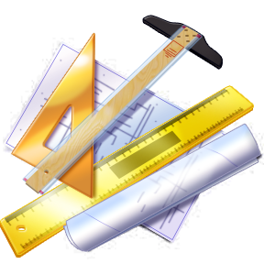
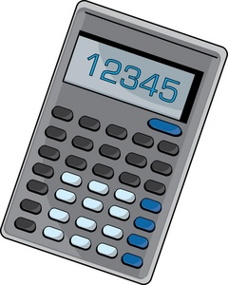
Name: _________________________
Period: ________________________
Date: _________________________
Summative 1.1, 1.2 Study Guide

Scientific Notation
Convert to scientific notation or standard form. Keep the number of significant figures the same as the given number.

- 3,456,320 __3.45632 x 10⁶_______ 4. 4.563 x 10⁻⁴ ____0.0004563_________

- 0.0004322 ___4.322 x 10⁻⁴__________ 5. 3.40 x 10¹ _____34.0______________

- 102.0 _____1.020 x 10²____________ 6. 7.8322 x 10⁰ ______7.8322__________

- 20,100 _____2.01 x 10⁴__________ 8. 2.41 x 10⁵ _____241,000____________

Significant Figures
Indicate the number of significant figures, and then round each to the number of significant figures specified.

Ex. 1.234 has 4 significant figures and, rounded to 2 significant figures, is 1.2

- 0.089 has 2 significant figures and, rounded to 1 significant figure, is 0.09

- 10,700 has 3 significant figures and, rounded to 2 significant figures, is 11,000

- 12,700.00 has 7 significant figures and, rounded to 1 significant figure, is 10,000

- 0.0009880 has 4 significant figures and, rounded to 2 significant figures, is 0.00099

- 201,000 has __3__ significant figures and, rounded to 2 significant figures, is _2.0 x 10⁵__

Rounding
Report the unrounded answer in the first blank, and then round the final answer correctly in the second blank.

Unrounded Answer Rounded (Final) Answer

Ex. 134.8 + 27.67 = 162.47 162.5

- 206.5 + 4.002 = _210.502___ ____210.5_____
- 6.341 + 102.0 = ___208.341_____ ____108.3______
- 8.001 – 6.7 = ___1.301_____ ____1.3________
- 3696.10 – 34.0010 = ____3662.099__ _____3662.10____
- 1.41 x 22.10 = ___31.161____ ___31.2________
- 3696.10 x 4.0010 = ___14788.0961_ _____14788_____
- 0.68 x 2.45 ÷ 5.912 = __0.28179973__ _____0.28______
- 2.1 x 354.98 ÷ 4.775 = _156.116859___ _____160_______
- 0.03325 x 1.99992 = ___0.06649734__ _____0.6650______

Dimensional Analysis Unit Conversions
Use dimensional analysis to convert the following. Show all work, units, and round your answer correctly.

- 340 µg = _____3.4 x 10⁸____ pg 29. 7250 mm = __725_ cm
340 µg x 1 g x 10¹² pg = 3.4 x 10⁸ pg 7250 mm x 1 m x 10² cm =
10⁶ µg 1 g 10³ mm 1 m

- 98 cm = ___39____ in 30. 9700 nL = __9.7_ µL
98cm x 1in = 38.582677 in 9700nL x 1L x 10⁶ nL = 9.7 µL
2.54cm 104 nL 1L

- 93 oz. = ___2600___ g 31. 0.3001 m = ___3.001 x 10 ⁻⁴__ km
93 oz x 28.3495 g = 2636.5035 0.3001 m x 10⁻³ = 0.0003001 km
1 oz 1 m

- 176 mg = ___1.76 x 108__ ng 32. 25 mg = __2.5_ cg
176 ng x 1 g x 109 ng = 176000000 ng 25 mg x 1 g x 10² cg = 2.5 cg
10³mg 1 g 10³ mg 1 g

- 20 m = ___800_ in. 33. 1,560 m = _0.970_ mi
20 m x 10² cm x 1 in = 787.40157 in 1560 m x 10⁻³ km x 1 mi = 0.969546
- m 2.54 cm 1 m 1.609 km

- 450 m/s = ___1.0x10³____ mi/hr 34. 5.70 g/mL = ___5.70x10⁹____ µg/L
450 m x 10⁻³ km x 1 mi x 60 s x 60 min = 5.70 g x 10⁶ug x 10³mL = 5.70x10⁹ µg/L
S 1 m 1.609km 1min 1hr mL 1 g 1 L

Perform the following unit conversions using dimensional analysis. Show all work, units, and round your answer.

- How many kilograms are in 175 lbs? 175 lbs x 1 kg = 79.5 kg
2.2lbs

- How many seconds are in 2 days? 2 days x 24 hrs x 60 min x 60 sec = 100000 sec
1day 1 hr 1min

- You are looking into hotels in Japan. The hotel you are looking into costs 38821 yen per night. How much would this cost in American dollars? ($1 = 102.70 ¥). 38821 yen x 1 dollar = $378.00
102.70yen

- Change 40 miles/hour into meters/second.

40 miles | 1.609 km | 1000 m | 1 hr | 1 min | 17.87 → 20 m/sec
hr | 1 mi | 1 km | 60 min | 60 sec

