LT 1.5: Properties of Matter Review

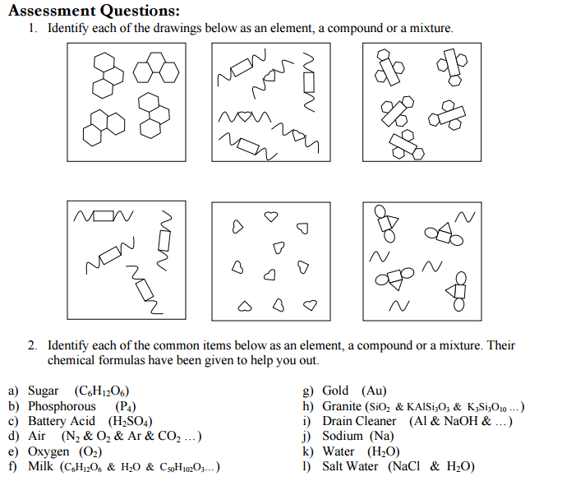  
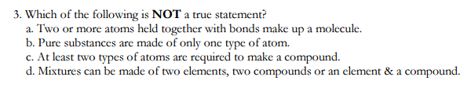

4. Explain your answer for #3. Write your answer in complete sentences.

5. Identify each of the following as a chemical or physical property.

1. ______ boiling point
2. ______ color
3. ______ acidity
4. ______ texture
5. ______ combustibility – the ability of an object to burn or ignite
6. ______ alka seltzer tablets fizz in water
7. ______ ice will melt if left on the table
8. ______ gasses in the air react with rain to make acid rain
9. ______ malleability – the ability of a substance to be hammered into a flat sheet
10. ______ density
11. ______ sugar dissolves in water

|  |  |  |
| --- | --- | --- |
| **PROBLEMS** | **WORK** | **ANSWERS** |
| 1. Convert 8.43 cm to millimeters |  |  |
| 2. Convert 2.43 X 103 cm to meters |  |  |
| 3. How many kilograms are in 120.52 lbs? |  |  |
| 4. Convert 1250 lbs to kilograms |  |  |
| 5. If a building is 1024.5 ft tall, how many meters is it? |  |  |
| 6. A 2 Liter bottle would hold how many quarts? |  |  |
| 7. Convert 550 mL to quarts |  |  |
| 8. Convert 9018 ounces to kilograms |  |  |
| 9. Your baby has a mass of 3.94 kg. How many lbs? |  |  |
| 10. Convert 294.85 cm to mm |  |  |

Name: ____________________________________________________________ Date: _______________ Period: _____

LT 1.1: Dimensional Analysis Review