LT 1.5: Properties of Matter Review

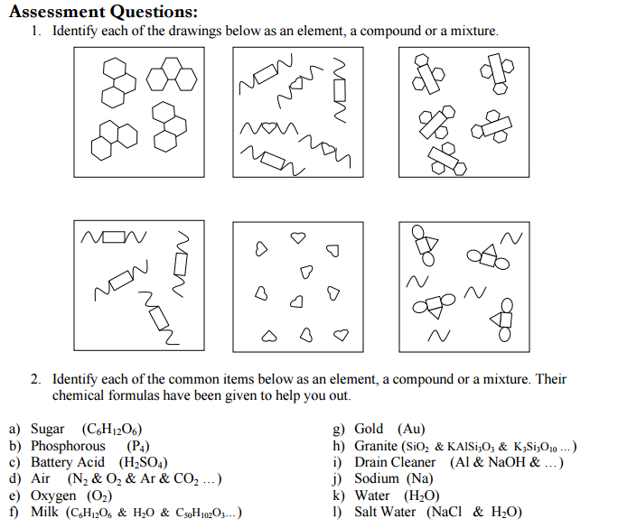

Element

Mixture (of Cmpds)

Compound

Compound

Element

Mixture (of E and C)

a) Compound g) Element

b) Element h) Mixture (of compounds)

c) Compound i) Mixture (of elements and compounds)

d) Mixture (of elements and compounds) j) Element

e) Element k) Compound

f) Mixture (of compounds) l) Mixture (of compounds)  
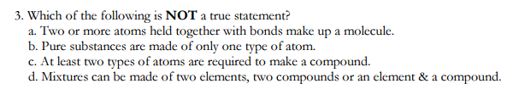

4. Explain your answer for #3. Write your answer in complete sentences.

A compound is considered a pure substance and they are made up of two+ types of atoms. For example water H2O and carbon dioxide CO2.

5. Identify each of the following as a chemical or physical property.

1. __PP__ boiling point
2. __ PP__ color
3. __ CP_ acidity
4. __ PP_ texture
5. __CP__ combustibility – the ability of an object to burn or ignite
6. __ CP__ alka seltzer tablets fizz in water
7. __ PP_ ice will melt if left on the table
8. __ CP__ gases in the air react with rain to make acid rain
9. _ PP__ malleability – the ability of a substance to be hammered into a flat sheet
10. _ PP_ density
11. __ PP__ sugar dissolves in water

|  |  |  |
| --- | --- | --- |
| **PROBLEMS** | **WORK** | **ANSWERS** |
| 1. Convert 8.43 cm to millimeters | |  |  |  | | --- | --- | --- | | 8.43 cm | 1000 mm | 84.3 mm | |  | 100 cm |  | | 84.3 mm |
| 2. Convert 2.43 X 103 cm to meters | |  |  |  | | --- | --- | --- | | 2.45x103 cm | 1 m | 24.5 m | |  | 100 cm |  | | 24.5 m |
| 3. How many kilograms are in 120.52 lbs? | |  |  |  |  |  | | --- | --- | --- | --- | --- | | 120.52 lbs | 16 oz | 28.35 g | 0.001 kg | 54.667872 | |  | 1 lbs | 1 oz | 1 g |  | | 54.668 kg |
| 4. Convert 1250 lbs to kilograms | |  |  |  |  |  | | --- | --- | --- | --- | --- | | 1250 lbs | 16 oz | 28.35 g | 0.001 kg | 567 | |  | 1 lbs | 1 oz | 1 g |  | | 567 kg |
| 5. If a building is 1024.5 ft tall, how many meters is it? | |  |  |  | | --- | --- | --- | | 1024.5 ft | 1 m | 312.2523 m | |  | 3.281 ft |  | | 312.25 m |
| 6. A 2 Liter bottle would hold how many quarts? | |  |  |  |  | | --- | --- | --- | --- | | 2 L | 0.264 gal | 4 qt | 2.112 qt | |  | 1 L | 1 gal |  | | 2 qt |
| 7. Convert 550 mL to quarts | |  |  |  |  |  | | --- | --- | --- | --- | --- | | 550 mL | 1 L | 0.264 gal | 4 qt | 0.5808 qt | |  | 1000 mL | 1 L | 1 gal |  | | 0.58 qt |
| 8. Convert 9018 ounces to kilograms | |  |  |  |  | | --- | --- | --- | --- | | 9018 oz | 28.35 g | 0.001 kg | 255.6603kg | |  | 1 oz | 1 g |  | | 255.7 kg |
| 9. Your baby has a mass of 3.94 kg. How many lbs? | |  |  |  |  | | --- | --- | --- | --- | | 3.94 kg | 1 g | 1 lb | 8.6862585 | |  | 0.001 kg | 453.59 g |  | | 8.69 lbs |
| 10. Convert 294.85 cm to mm | |  |  |  | | --- | --- | --- | | 294.85 cm | 1000 mm | 2948.5 mm | |  | 100 cm |  | | 2948.5 mm |

Name: ___________ANSWER KEY______________________________________ Date: _______________ Period: _____

LT 1.1: Dimensional Analysis Review