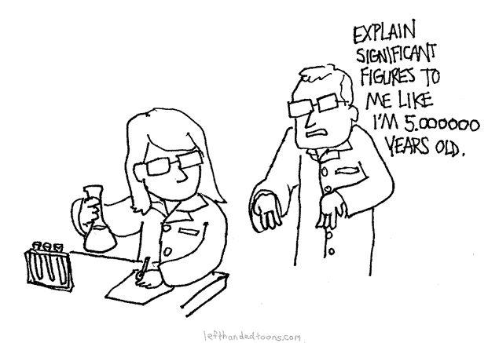Significant Figures Reflection

Open your notebooks to the next available page. Title the page “Significant Figures”, label it with a circle (to mark it’s a reflection) and write today’s date. Follow the activity instructions below.

* This symbol marks an answer that needs to be written in your notebook. Write your answers in complete sentences. This entry will act as your significant figure notes.

**Non-Zero Digits**

341 – 3 significant figures

3.993 – 4 significant figures

7,777 – 4 significant figures

123.456 – 6 significant figures

98. – 2 significant figures

5 – 1 significant figure

66.8 – 3 significant figures

21 – 2 significant figures

All the numbers above contain only **non-zero digits.** Examine the numbers with your group. Discuss what patterns you see. What are non-zero digits? All the significant digits in the number have been underlined. When are they non-zero digits significant? How do duplicate numbers affect the amount of significant figures?

* In your notebook, define non-zero digits. (remember: use a complete sentence!)
* In your notebook, write a rule explaining how to count significant figures for non-zero digits. Give at least 2 examples. (remember: use a complete sentence!)

**Sandwiched (Captive) Zeros**

201 – 3 significant figures

30,005 – 5 significant figures

10.01 – 4 significant figures

10,907 – 5 significant figures

105.1 – 4 significant figures

54.607 – 5 significant figure

1,000.505 – 7 significant figures

302 – 3 significant figures

All the numbers above contain only non-zero numbers and **captive zeros.** Examine the numbers with your group. Discuss what patterns you see. What are captive zeros? All the significant digits in the number have been underlined. When are captive zeros significant? Does the decimal point affect whether or not a captive zero is significant?

* In your notebook, define captive zeros. (remember: use a complete sentence!)
* In your notebook, write a rule explaining how to count significant figures for numbers with captive zeros. Give at least 2 examples. (remember: use a complete sentence!)

**Leading Zeros**

0.0053 – 2 significant figures

0.0549 – 3 significant figures

0.1234 – 4 significant figures

0.0000976 – 3 significant figures

0.00491 – 3 significant figures

00456.4 – 4 significant figure

00048.912 – 5 significant figures

0843 – 3 significant figures

All the numbers above contain only non-zero numbers and **leading zeros.** Examine the numbers with your group. Discuss what patterns you see. What are leading zeros? Only the significant digits in the number have been underlined. When are leading zeros significant? Does it matter whether they are before or after the decimal point?

* In your notebook, define leading zeros. (remember: use a complete sentence!)
* In your notebook, write a rule explaining how to count significant figures for numbers with leading zeros. Give at least 2 examples. (remember: use a complete sentence!)

**Trailing Zeros**

70.0 – 3 significant figures

3,400. – 4 significant figures

20.00 – 4 significant figures

3,000.0 – 5 significant figures

4500 – 2 significant figures

10 – 1 significant figure

56,780 – 4 significant figures

34,000,000 – 2 significant figures

All the numbers above contain only non-zero numbers and **trailing zeros.** Examine the numbers with your group. Discuss what patterns you see. What are trailing zeros? Only the significant digits in the number have been underlined. When are trailing zeros significant? How does the decimal point affect whether or not they are significant? Does it matter whether they are before or after the decimal point?

* In your notebook, define trailing zeros. (remember: use a complete sentence!)
* In your notebook, write a rule explaining how to count significant figures for numbers with trailing zeros. Give at least 4 examples. (remember: use a complete sentence!)

**Practice**

For each of the following, count the number of significant figures, then circle all the rules that apply to the number. Do this using a whiteboard marker on the sheet protector.

| **Number** | **Significant Figures** | **Rules That Apply** |
| --- | --- | --- |
| 30,456 |  | No-Zero Digits Sandwiched Zeros  Leading Zeros Trailing Zeros |
| 0.00509 |  | No-Zero Digits Sandwiched Zeros  Leading Zeros Trailing Zeros |
| 307.80 |  | No-Zero Digits Sandwiched Zeros  Leading Zeros Trailing Zeros |
| 80,900 |  | No-Zero Digits Sandwiched Zeros  Leading Zeros Trailing Zeros |
| 0.450 |  | No-Zero Digits Sandwiched Zeros  Leading Zeros Trailing Zeros |
| 2,777 |  | No-Zero Digits Sandwiched Zeros  Leading Zeros Trailing Zeros |
| 9,000 |  | No-Zero Digits Sandwiched Zeros  Leading Zeros Trailing Zeros |
| 0.00045000 |  | No-Zero Digits Sandwiched Zeros  Leading Zeros Trailing Zeros |
| 400.0 |  | No-Zero Digits Sandwiched Zeros  Leading Zeros Trailing Zeros |
| 030078 |  | No-Zero Digits Sandwiched Zeros  Leading Zeros Trailing Zeros |