Name: _______________________________________________ Date: ______________________________ Period: _________

**Summative 3.1, 3.2, 3.3 Study Guide**

**Learning Target 3.1**

1. Complete the following table.

|  |  |  |  |  |  |  |  |
| --- | --- | --- | --- | --- | --- | --- | --- |
| Element | Symbol | Atomic # | Atomic Mass | # protons | # neutrons | # electrons | Nuclear Symbol |
| Argon |  |  |  |  |  |  |  |
|  | Cd |  |  |  |  |  |  |
|  |  | 59 |  |  |  |  |  |
|  |  |  | 207 |  |  |  |  |
|  |  |  |  |  |  |  | $\begin{matrix}184 \\ 74\end{matrix}$ W |

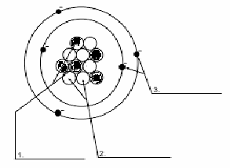**Learning Target 3.2**

1. Label the parts of the atom to the right. What is the charge on each subatomic particle? Identify where the mass is located and where the volume is located.
2. Draw Bohr models for Lithium, Calcium, Neon, and Phosphorous. How many valence electrons does each one have?

**Learning Target 3.3**

1. Complete the following table.

|  |  |  |  |  |  |  |  |
| --- | --- | --- | --- | --- | --- | --- | --- |
| Element | Ion Symbol | Atomic # | Atomic Mass | # protons | # neutrons | # electrons | Nuclear Symbol (include charge) |
|  | Co2+ |  |  |  |  |  | Co2+ |
|  |  |  |  | 13 |  | 10 |  |
|  |  | 46 |  |  |  | 44 |  |
|  | Cs2+ |  |  |  |  |  |  |
| Iodine (-1) |  |  |  |  |  |  |  |

1. Why does iodine form an ion? (Use stable octet and valence electrons in your answer)