Name: _____________________________________________ Date: ____________________________ Period: _______

LT 2.3: Salt Water Density Lab

**Essential Questions:** How is density determined? How does density relate to floating and sinking?

**Materials:**

Salt Water Electronic scale Assorted glassware

Food Coloring Spoons Test tubes Test tube rack

Weigh boat Pipet Parafilm

**Procedure**

1. Measure 3.0 grams of salt into the weigh boat using the scale.
2. Add the salt to the 10mL graduated cylinder.
3. Add 1 drop of food coloring (your choice which color)
4. Fill the graduated cylinder with water to the 10.0 mL line.
5. Pour your solution into a test tube for safe keeping. On a piece of scratch paper, label the test tube 30%.
6. Repeat steps 1-5, using 1.0 grams of salt. Add a DIFFERENT COLOR food dye to your graduated cylinder. Label the test tube 10% on your scratch paper.
7. Repeat steps 1-5, using 0.1 grams of salt. Add a DIFFERENT COLOR food dye to your graduated cylinder. Label the test tube 1% on your scratch paper.

In the space provided below, **create a model** of the three solutions. Make a drawing of each solution—if you could zoom all the way in, what would you expect to see? You should include the water molecules, salt molecules and food coloring molecules in your diagrams.

Include a key showing what each particle is.

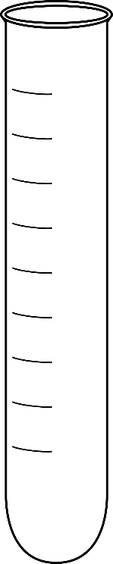**Prediction:** If you carefully poured all three solutions into a test tube, what would you expect to see? Draw your prediction into the test tube to the right. Explain why you expect to see this.

**Density Lab Calculations**

Using the procedure provided, record the mass and volume of each solution you created in the table below, then calculate the density. Then create your density column!

Table 1: ______________________________________________________ Date: ______________

(Give your data table a descriptive title!)

|  |  |  |  |  |  |  |
| --- | --- | --- | --- | --- | --- | --- |
| Solution | Color | Mass of empty graduated cylinder (g) | Mass of graduated cylinder + salt + food coloring + water (g) | Mass of solution (g)  (column 4 – col 3) | Volume of solution (mL) | Density of Solution (g/mL) |
| 30% |  |  |  |  |  |  |
| 10% |  |  |  |  |  |  |
| 1% |  |  |  |  |  |  |

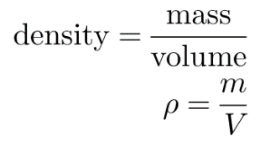

Determine the density of each solution using the equation. Show an example calculation below:

**Conclusion** *(please answer in complete sentences)*

Was your prediction correct? How did the density of the solution effect its location in the density column? Construct an explanation for why you saw the layers separate in the order you did in your test tube.

_______________________________________________________________________________________________________________________________________________________________________________________________________________________________________________________________________________________________________________________________________________________________________________________________________________________________

______________________________________________________________________________________________________________________________________________________________________

______________________________________________________________________________________________________________________________________________________________________