Name: ___________________________________________ Date: _____________________________ Period: ________

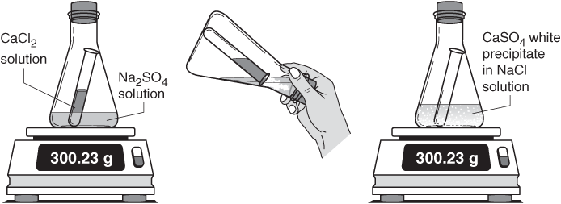

Law of Conservation of Matter Lab

**Essential Question:** What is Matter and the Law of Conservation of Matter?

**Objective:** To create and perform an experiment to demonstrate the Law of Conservation of Mass

**Engage and Explain:**

*After watching the demo, answer the following questions.*

1. Describe what happens when the vinegar was poured into the cup of baking soda:
2. What evidence do you have that a chemical reaction took place?
3. What is the law of conservation of mass? Does this demo demonstrate the law of conservation of mass? Why or why not?
4. The gas produced in this reaction can put out fires. Can you make an educated guess about its identity? What is the name of the gas?

**Explore and Elaborate:**

With your group members, you will design an investigation to demonstrate the law of conservation of mass using baking soda and vinegar. Be specific in your procedures so another person or group could reproduce your investigation and gather the same data and observations. Once the procedures are written, conduct your investigation. Be sure to collect data and observations during each trial. If you change your procedures along the way, make adjustments to your procedures on paper.

**Materials available to design your experiment:**  ***All students must wear googles!***

* Erlenmeyer Flasks (125 mL) - Baking soda
* Beakers (various sizes) - Vinegar
* Ziploc bags (various sizes) - Balloons
* Test tubes - Electronic scale
* Graduated cylinders (various sizes) - Plastic cups (various sizes)
* **Other materials you might like to experiment with, just ask Mrs. Macedo – she might have it lying around!

**Materials used in your experiment:**

______________________ ______________________ ______________________ ______________________ ______________________ ______________________

______________________ ______________________ ______________________

**Procedure:** *(To be completed on a separate sheet of paper – write neatly and number each step!)*

Things to include – what type of glassware & sizes, which chemicals & amounts, diagrams/drawings to help explain your set up. You numbered procedure steps should be written in complete sentences.

**Results:** *(To be completed on a separate sheet of paper)*

Should include both quantitative measurements and qualitative observations. Data Table! Include calculations (with the work) where needed.

**Explanation of Results:**

Claim: My experiment did / did not (circle one) demonstrate the law of conservation of matter.

Evidence: ___________________________________________________________________________________

___________________________________________________________________________________________

___________________________________________________________________________________________

___________________________________________________________________________________________

___________________________________________________________________________________________

Reasoning: Should answer the following questions

* Was this the result you expected to get? Why or why not.
* Why did (or didn’t) your evidence demonstrate the law.
* If your experiment did not demonstrate the law, propose an explanation for why it didn’t.

___________________________________________________________________________________________

___________________________________________________________________________________________

___________________________________________________________________________________________

___________________________________________________________________________________________

___________________________________________________________________________________________

___________________________________________________________________________________________

___________________________________________________________________________________________

___________________________________________________________________________________________

___________________________________________________________________________________________

___________________________________________________________________________________________

___________________________________________________________________________________________

___________________________________________________________________________________________

___________________________________________________________________________________________