**Systems, Energy and Kinetic Molecular Theory Notes**

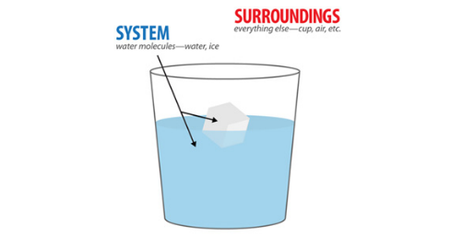

Open System vs. Closed System: ________________________________________________

___________________________________________________________________________

___________________________________________________________________________

Inputs: _____________________________________________________________________

Outputs: ___________________________________________________________________

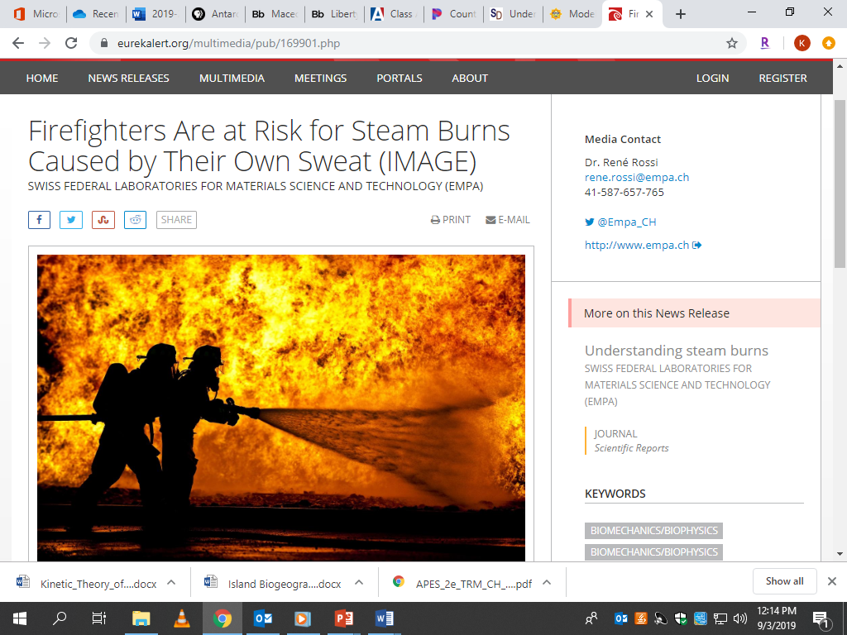

Read the article headline to the left and complete the sentence starters below.

I notice…

It reminds me of…

I wonder…

Could it be…?

Brainstorm answers with your table group and write down your initial thoughts.

1. How does their sweat turn into steam?
2. Why is a steam burn worse than a hot water burn?

Kinetic Energy: __________________________________ vs. Potential Energy: __________________________________

Kinetic Molecular Theory: All matter consists of tiny particles that are in __________________ , ________________ __________________.

| State of Matter | Solid | Liquid | Gas |
| --- | --- | --- | --- |
| Volume & Shape | Definite volume & shape  “tightly packed” | Definite Volume  No Definite Shape  “loosely packed” | No definite volume or shape  “lots of space” |
| Motion | Vibrational & Rotational | Vibrational, rotational, and translational | Random |
| Kinetic Energy | Low | Medium | High |
| Attractive Forces | Strong | Moderate | Weak |

To Summarize: Why is a steam burn worse than a hot water burn?