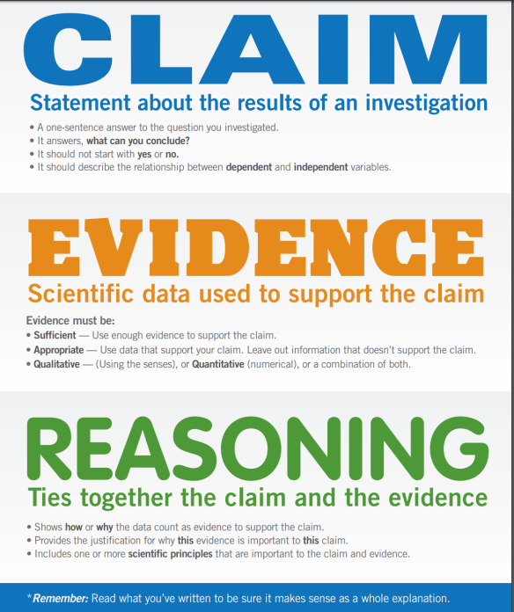**Tips for your claim:**

Make sure your claim is specific and uses key vocabulary from your investigations.

Avoid using openings like “I think” or “I believe”.

**Sentence starters for evidence:**

“This experiment showed that…”

“In the first trial…”

“We observed…”

“The data shows…”

Make sure your evidence has the data (numbers or observations) you got out of your lab. Make sure to say how you got those observations (how was the experiment set up).

**Sentence starters for reasoning:**

“This happened because…”

“The results can be explained by…”

“This evidence shows…”

“The evidence supports the claim because…”

“This is significant because…”

If there are potential counter-arguments against your claim, address them here (explain why they are wrong and your answer is right!).

Make sure to explain the science behind why it works!

**Tips for your claim:**

Make sure your claim is specific and uses key vocabulary from your investigations.

Avoid using openings like “I think” or “I believe”.

**Sentence starters for evidence:**

“This experiment showed that…”

“In the first trial…”

“We observed…”

“The data shows…”

Make sure your evidence has the data (numbers or observations) you got out of your lab. Make sure to say how you got those observations (how was the experiment set up).

**Sentence starters for reasoning:**

“This happened because…”

“The results can be explained by…”

“This evidence shows…”

“The evidence supports the claim because…”

“This is significant because…”

If there are potential counter-arguments against your claim, address them here (explain why they are wrong and your answer is right!).

Make sure to explain the science behind why it works!