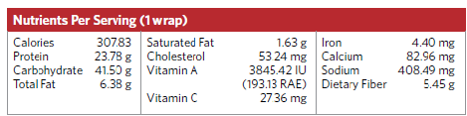

**Ingredients:**

Whole wheat tortillas, fresh shredded carrots, broccoli & spinach, diced chicken, crushed pineapple, light mayo, poppy seeds, sugar, onion powder, garlic powder, chili powder